Wheeled Impact Crusher
Brief Introduction:
Wheeled Impact Crusher is often used in the site where you may need to change working site often, especially when you process stones used in high way, railway and so on. Therefore, Mobile Impact Crusher needs to be designed specifically for clients according to different materials, scale and requirement of the final products. Wheeled Impact Crusher can be applied in the industry of metallurgy, chemical, building materials, water power station. The integration unit is easy for installation and maintenance. This makes the whole Wheeled Crusher Plant take the features of longer working time and higher durability.
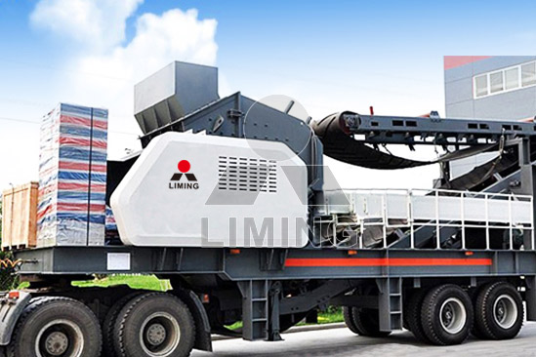
Highlights:
(1) Compact design and integrated unit. Screening equipment, belt conveyors, impact crusher and other auxiliary equipment are mounted together in one truck trailer
(2) Trailer mounted and easy for transportation.
(3) Automatic operation and easy maintenance. Mobile crushing plant is controlled by electrical control panels. And it is mounted with convenient equipment, such as elevator which facilitates the maintenance and operation monitoring.
(4) Flexible and efficient. As mobile crusher is integrated, so it can work independently. Besides, according to different material types and final product requests, mobile crushers technical plan are adjustable.
(5) With support legs on the trailer (or track), easy for installation.
(6) Truck trailer-mounted motor and electrical control panel is integrated and compact.
Working Principle:
When the mobile impact crusher work, the rotor rotating high-speed under the motor is drove, then the materials into the function area of plate hammer and impact crushing with the plate hammer in rotor. Later break again in the counterattack device. And bounce back the plate hammer function area again to break from the counterattack foils. This process is repeated, until the materials being broken into the needed particle size and deduction by the discharging mouth.
Technical Data:
Model  Technical data | Y3S154F1010 | Y3S184F1210 | Y3S186F1214 | Y3S216F1315
Transportation Length (mm) | 11000 | 11600 | 12800 | 13500
Transportation Width (mm) | 2450 | 2800 | 2800 | 3000
Transportation Height (mm) | 3900 | 4400 | 4400 | 4500
Maximum Length (mm) | 12700 | 13500 | 15500 | 16200
Maximum width (mm) | 2800 | 3150 | 3150 | 3500
Maximum Height (mm) | 5700 | 6000 | 6400 | 6700
Weight (T) | 34 | 40 | 45 | 56
Tire Configuration | Dualaxial | Dualaxial | Triaxial | Triaxial
Impact crusher | PF-1010 | PF-1210 | PF-1214 | PF-1315
Feed opening size | 400*1080 | 400*1080 | 400*1430 | 860*1520
The maximum Feeding size (mm) | 350 | 350 | 350 | 500
Capacity (T/h) | 50-250 | 70-300 | 90-400 | 120-450
Belt conveyor | B650X7M | B650X7M | B800X8M | B800X8M
Vibrating Screen | 3YZS1548 | 3YZS1848 | 3YZS1860 | 3YZS2160

Contact Us:
Thank you for your interest in Liming Heavy Industry (Shanghai). Please feel free to use any of the methods below to get in touch with us.
Office Tel: 0086-21-33901608
Fax: 0086-21-58377628
Email: sales@shcrusher.com
MSN Online: shcrusher@hotmail.com
Address: No.201-34, Huaxia 3rd Road, Pudong New Area, Shanghai, China.
Postcode: 201200

For more detailed information, please click here: http://www.shanghai-crusher.com/

