Product

Brief Introduction:

The vibrating feeder is also called “vibrating feeding machine”. The GZD series vibrating feeder manufactured by our company is a new-type vibrating feeder specially designed for uniformly conveying bulk materials before the medium crushing and coarse crushing process .This type of feeder adopts a structure with the double-eccentric-shaft exciter, which ensures the equipment to bear the impact caused by lump material falling, so the feeding material capability is very large. In the process of production, the lump and particle material can be fed into the material receiving device from the storage bin uniformly, regularly and continuously, so as to avoid the system halting, thus, the service life of the equipments is prolonged.

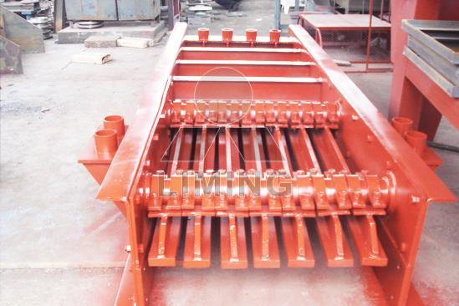

Highlights:

(1) It is of even vibration, reliable operation, long life.

(2) Its vibration force can be adjusted. The flow quantify can be changed and controlled any time.

(3) Motor is the excitation source, with low noise, low power consumption, and good adjusting capability.

(4) The structure is simple, it performances reliable, and it is light, small, and easy for adjustment and installation. It can avoid powder and dust when using the sealed body.

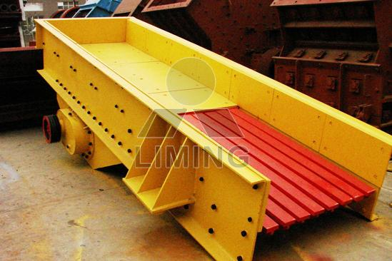

Working Principle:

The vibrating feeder consists of a feeding tank, exciter, a spring support and a transmission device. The vibrating source for the vibrating feed for the tank is the exciter. The exciter consists of two eccentric axes (positive and negative) and a gear pair. The motor drives the positive axis through the V-belt, then, the gear on the positive axis will mesh with the negative axis, in this case, the positive axis and negative axis contra-rotate at the same time, to make the tank vibrate, thus the material will flow continuously, and the purpose of conveying the material is achieved.

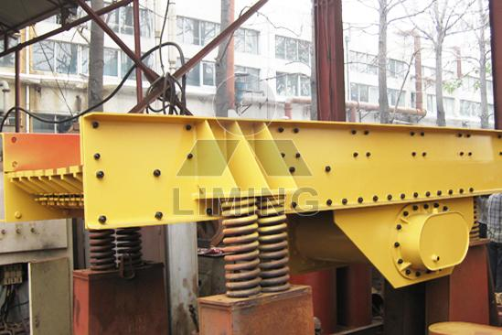

Technical Data:
Model | Feed chute size (mm) | Max. feeding size (mm) | Handling capacity (t/h) | Power (Kw) | Overall dimension (mm) | Weight (including motor) (kgs)
GZD-960×3800 | 960×3800 | 500 | 120-210 | 11 | 3880×2240×1880 | 3980
GZD-1100×4200 | 1100×4200 | 580 | 200-300 | 15 | 4300×2450×2010 | 4170
GZD-1300×4900 | 1300×4900 | 650 | 300-450 | 22 | 4980×2705×2050 | 5200
GZD-1500x6000 | 1500x6000 | 800 | 460-800 | 30 | 6160x2920x2295 | 9000

Contact Us:
Thank you for your interest in Liming Heavy Industry (Shanghai). Please feel free to use any of the methods below to get in touch with us.
Office Tel: 0086-21-33901608
Fax: 0086-21-58377628
Email: sales@shcrusher.com
MSN Online: shcrusher@hotmail.com
Address: No.201-34, Huaxia 3rd Road, Pudong New Area, Shanghai, China.
Postcode: 201200

For more detailed information, please click here:
http://www.shanghai-crusher.com/

