VSI Sand Making Machine
Brief Introduction:
VSI sand making machine (also named VSI vertical shaft impact crusher) is newly developed equipment, based on our engineers’ many years’ R&D, absorbing the advanced technique overseas, with international advanced stage. It is of high efficient energy-saving crusher. Its good performance plays a irreplaceable role in the crushing of all kinds of ores. This crusher is widely used in crushing and reshaping of metallic and non-metallic ore, building material, artificial sand and all kinds of metallurgical slag.
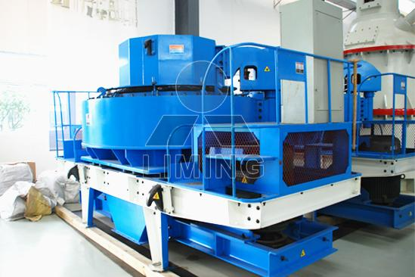
Highlights:
1. Large processing capacity and high output -50-500t/h. The output is increased by 30% compared with traditional equipment under same power and it is stable.
2. Low consumption of wearing parts — with optimal hitting-angle design for material of crushing cavity and little friction with wear resistant parts, the operation expense is lower than that of traditional equipment by 30%, which directly decreases using cost of equipment.
3. Excellent grain shape of product — product is in cubic shape with good grain shape, reasonable gradation and adjustable fineness modulus; it is especially applicable to man-made sanding and stone shaping. Practice shows that: its sanding and shaping effect are higher than that of other traditional equipments improved by 30%.
4. Hydraulic device and easy maintenance — hydraulic hood opening device makes internal parts of crushing cavity be conveniently and rapidly maintained, dismantled and changed, which shortens dead time and saves both time and labor.
5. Automatic detection, safety and reliability — having set over vibration display and warning device, which will give out warning to make equipment stop working if bad operation occurs on equipments, thereby reaching the purpose of protecting machines.
6. Thin oil lubrication and automatic maintenance — German original thin oil lubrication station, double oil pump is supplementary to each other to guarantee oil supply; automatically power off if there is oil flow and oil pressure; oil fluid cooling and heating device can guarantee that bearing lubricating is always under the best status, thereby thoroughly solving problems such as bearing heating, keeping spindle bearing at constant temperature, prolonging maintenance intervals and service life.
7. Simple and convenient installation and easy operation — light weight of equipment, various installation modes and mobile type installation; simple installation, maintenance and convenient operation and use; as soon as concrete usage is confirmed, you will only need to make fine adjustment on VSI sand maker, which will give play to outstanding performance to the utmost extent.
8. Multi-use machine and flexible application — It has unique feeding and crushing structure and many kinds of shapes of crushing cavity, which can very conveniently realize conversion between "Using stone to hit stone" and "Using stone to hit iron block", thereby solving the difficulty of multi-use machine. If application of VSI crusher is to be changed, it can be applicable to different demand of users without making big adjustment: man-made sand making, broken stone shaping and abrasive material etc.
9. International quality assurance — The application of German latest technology process, advanced riveting technology, appearance blasting and de-rusting treatment of auto technology and application of painting technology, have greatly improved internal quality and appearance quality of equipment. International famous brand is adopted for kernel components (TIMKEN roller bearing with high precision grade is adopted for bearing) to guarantee low failure rate of the system.
10. Attaching importance to environmental protection — sand-making equipment produces small noise at work without pollution. Unique air self-circulation system greatly decreases the volume of exhausted air and dust, benefit to environment. Furthermore, VSI sand maker reserves and adapts to installing dust-removing equipment with many specifications.
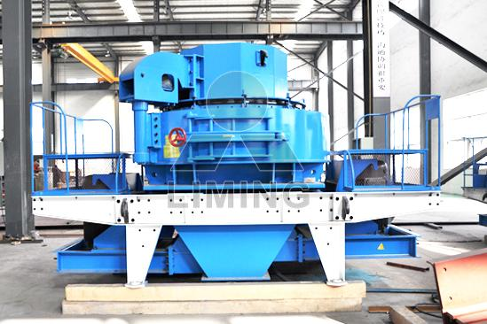
Working Principle:
VSI Sand Making Machine adopts advanced principle of selective crushing and cleavage fracture crushing; impressing enough kinetic energy to materials; Impacting strength will convert kinetic energy to crushing energy. Materials will break through the natural lamination and physical edge. It has the features of better shape of final products, but less cost. This machine can realize two working principles' conversion with "crushing between materials" and "crushing between materials and liners".
Technical Data:
Model |  | VSI7611 | VSI8518 | VSI9526 | VSI1140
Capacity (t/h) | Center and Ring feeding | 120-180 | 200-260 | 300-380 | 450-520
Capacity (t/h) | Center feeding | 60-90 | 100-130 | 150-190 | 225-260
Max Feed Size (mm) | Soft material | <35 | <40 | <45 | <50
Max Feed Size (mm) | Hard material | <30 | <35 | <40 | <45
Rotation speed (r/min) |  | 1700-1890 | 1520-1690 | 1360-1510 | 1180-1310
Power for double motor (kW) |  | 110 | 180 | 264 | 400
Overall Dimension L×W×H (mm) |  | 4100×2250  ×2285 | 4140×2280  ×2425 | 4560×2450  ×2780 | 5100×2690  ×3200
Weight (t) |  | 7.8 | 10.3 | 16 | 25.6
Power Source |  | 380v 50Hz
Vibrating Sensor |  | Inspect scope: 0.1-20mm/s adjusted continuously
Lubrication hydraulic pressure station | Power for double oil pump | 2×0.31kW
Lubrication hydraulic pressure station | Safety | To make sure the supply of the oil with double oil pump; stop working without oil or hydraulic pressure; temperature falls when the water cools; start the motor by heating it in winter.
Lubrication hydraulic pressure station | Overall dimension  LxWxH(mm) | 820x520x1270
Lubrication hydraulic pressure station | Power for oil box heater | 2 kW
Notice: Any change of VSI Sand Making Machine technical data shall not be advised additionally.
Contact Us:
Thank you for your interest in Liming Heavy Industry (Shanghai). Please feel free to use any of the methods below to get in touch with us.
Office Tel: 0086-21-33901608
Fax: 0086-21-58377628
Email: sales@shcrusher.com
MSN Online: shcrusher@hotmail.com
Address: No.201-34, Huaxia 3rd Road, Pudong New Area, Shanghai, China.
Postcode: 201200

For more detailed information, please click here: http://www.shanghai-crusher.com/

