VSI5X Vertical Shaft Impact Crusher
Brief Introduction:
VSI5X Vertical Shaft Impact Crusher is integrated with three kinds of crushing modes and becomes core equipment in sand making industry. Through special optimal design, throughout capacity of material is improved by about 30% for deep-cavity shape rotor for VSI5X sand making machine. Innovation design is adopted for guard board, improving service life by more than 48%. Addition of secondary hammer can effectively avoid damaging riser after main ram is worn. The most crucial wear resistant materials adopt highly anti-wear and heat-resisting material used in important industries in America. Hydraulic hood opening device adopting originally imported parts can facilitate checking and maintaining equipments.
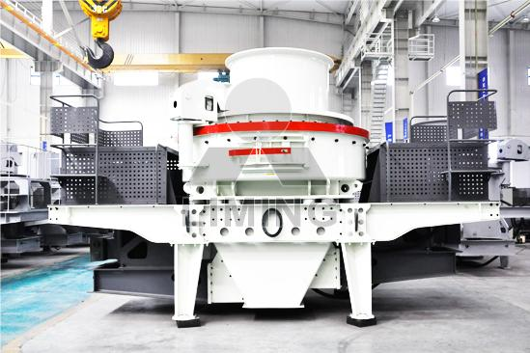
Highlights:
(1) After deep-cavity shape rotor is optimally designed, throughout capacity of material is improved by about 30%.
(2) After guard board is partially worn, its direction can be changed upward and downward, to improve usage rate of material; service life can be improved by more than 48%.
(3) Combinatory ram design: only need to replace the part of worn ram, which can lower using cost by more than 30%. Furthermore, addition of secondary ram can effectively avoid damaging riser after main ram is worn.
(4) The most crucial wear resistant materials adopts highly anti-wear and heat-resisting material used in important industries in America.
(5) Adoption of rhomboid impact block can avoid damaging riser after material is impacted and worn.
(6) Bearing is selected from international brands from Japan, Sweden and America etc.
(7) Optimal ejecting port and internal smoother curved form design can lower flow resistance of material and greatly improve throughput capacity of material.
(8) Dual purpose bulk panel ensures simple operation and convenient conversion between two kinds of feeding modes.
(9) Special sealing structure at lower end of spindle guarantees no leakage without oil sealing.
(10) Hydraulic hood opening device adopting originally imported parts from Japan makes movement of upper cover convenient and rapid, which saves strength when replacing and maintaining parts inside the main body.
(11) Selection of high degrees of protection motor. Such type of motor has the features of high efficiency and low noise, in accordance with standard of International Electrotechnical Commission (IEC), F grade insulation and IP54/55 degree of protection.
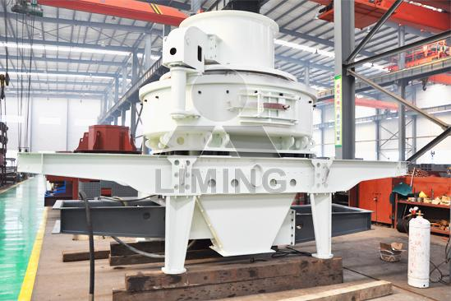
Working Principle:
Feed at center: Materials fall into the hopper and then through the feeding opening in the center enter the high speed rotor which will throw out the materials with high speed. Materials firstly strike those materials that are free falling down. Then, materials strike the materials-liner in the vortex or the impact liner and are rebounded to the top of crushing chamber and then fall down. After that, the falling materials with materials shot from the impeller form a continuous materials curtain. Ultimately, crushed materials will be charged from the discharging opening.
Feed both in the center and from sides: The materials fall into the hopper and the circle hole and then will be divided into two parts by the distributing plate. One part of materials cross the distributing plate and enter the high speed impeller and then is accelerated and thrown out. The other part falls down from the sides of distributor. Materials firstly strike the free falling down materials. Then, materials strike the materials-liner in the vortex or the impact liner and are rebounded to the top of crushing cavity and then fall down. The falling materials with materials shot from the impeller form a continuous curtain of materials. At last, crushed materials will be discharged from the discharging opening.
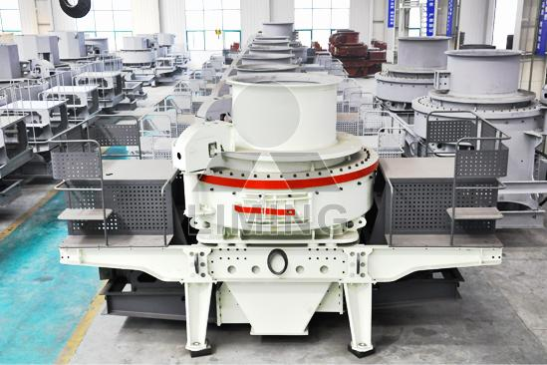
Technical Data:
1. Main technical parameters:
model |  | VSI5X7615 | VSI5X8522 | VSI5X9532 | VSI5X1145
Throughput capacity (t/h) | Center and Ring feeding | 150~280 | 240~380 | 350~540 | 500~640
Throughput capacity (t/h) | Center feeding | 70~140 | 120~200 | 180~280 | 250~360
Max. Feed Size (mm) | Soft material | <35 | <40 | <45 | <50
Max. Feed Size (mm) | Hard material | <30 | <35 | <40 | <45
Rotation speed (r/min) |  | 1700~1900 | 1500~1700 | 1300~1510 | 1100~1310
Power of double motor (KW) |  | 150 | 220 | 320 | 440
Overall dimension L x W x H (mm) |  | 4100×2330×  2300 | 4140×2500×  2700 | 4560×2600×  2900 | 5000×2790×  3320
Weight (t) |  | 8.6 | 11.8 | 17.5 | 27.5
Power source |  | 380v，50Hz
Thin oil lubrication station | Power for double oil pump | 2 x 0.37 KW
Thin oil lubrication station | Safety | To make sure the supply of oil with double oil pump, working without oil, temperature when water cools, start the motor by heating it in winter.
Thin oil lubrication station | Power for oil box heater | 2 KW
Thin oil lubrication station | Overall dimension  L x W x H (mm) | 820 x 520 x 1270
Note: Capacity depends on crushing limestone, material size, moisture and features also affect capacity.
2. Lubricating system parameter:
Oil box volume (L) | 240
Rated pressure (MPa) | 0.63
Flow capacity (L/min) | 8
Power (KW) | 0.31
Cooling water consumption (m3/h) | ≥1.2
Electrical heating voltage (V) | 220
Medium | Bearing oil 32—46#
Notice: Any change of VSI5X Vertical Shaft Impact Crusher technical data shall not be advised additionally.
Contact Us:
Thank you for your interest in Liming Heavy Industry (Shanghai). Please feel free to use any of the methods below to get in touch with us.
Office Tel: 0086-21-33901608
Fax: 0086-21-58377628
Email: sales@shcrusher.com
MSN Online: shcrusher@hotmail.com
Address: No.201-34, Huaxia 3rd Road, Pudong New Area, Shanghai, China.
Postcode: 201200

For more detailed information, please click here: http://www.shanghai-crusher.com/

