Product

Brief Introduction:

Ultrafine Millis designed by Liming engineers and technicians on the basis of many years production experience, such as multiple innovation. We have been absorbing many technology advantages from the same field home and abroad. The Ultrafine Mill has been proved by our thousands of customers to be out-standing and stable grinding mill.

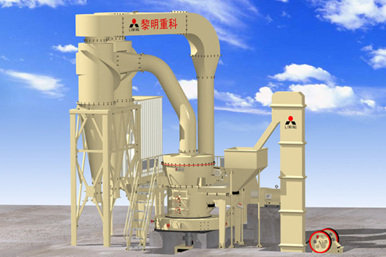

Highlights:

(1) The main frame and the base are completely soft-linked rather than rigid-contacted.

(2) The base is made of anti-crack nodular cast iron which boasts the strength of cast steel, the anti-vibration of cast iron and good impact resistance.

(3) It adopts the reducer that simulates German Flender.

(4) The main frame and reducer are connected by pin coupling with elastic sleeve to ward off the breaking of nylon pin, which improves the reliability of the whole equipment.

(5) The classifier adopts high density impeller which can improve the fineness and capacity.

(6) The classifier adopts frequency control of motor speed with the characteristics of energy-saving, precision, good process control mobility and high degree of automation.

(7) Bypass powder collector with a dust isolation chamber make more dust go into the bottom of cyclone by the bypass system to avoid the dust escaping from air vents.

(8) Same resistance arrangement avoids difference in power from two powder collector, which increases the efficiency, capacity and decreases internal circulation.

(9) The discharges of the collector and dust remover are in the same line which is convenient for powder collecting and packing and reduces the amount of work.

(10) The maintenance platform makes maintenance work safer and more convenient.

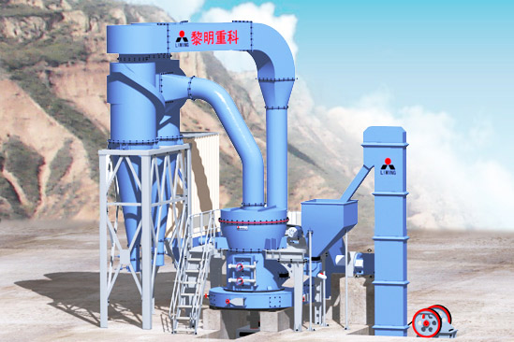

Working Principle:

The main motor of Ultrafine Mill drives main axle and every layer rotating by the power of reducer. Dial drives numbers of rollers rolling and rotating in the ring by pintles. Big materials are crushed into small particles by hammer crusher. Then they are sent to store house by elevator. Vibrating feeder send the materials evenly to the middle of the upper dial. Under the function of the eccentricity, the materials fall into the ring to be pressed, crushed and milled into pieces by rollers. After the first crush, materials fall into the second and third layer of the grinder mill. The pumping of the high-pressure centrifugal blower put the outside air into the ultra-fine mill. The coarse powder will be brought into the classifier.

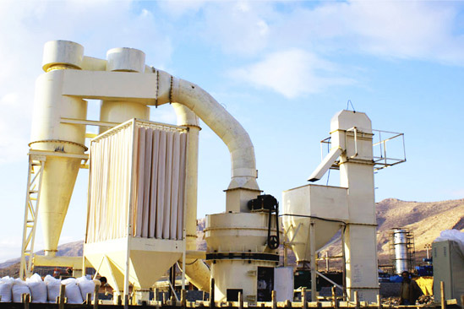

Technical Data:
1) Mainframe parameters
Item | Unit | Specifications &Technical data
Quantity of roller | pcs | 4
Diameter of roller x Height | mm | φ410×210
Diameter of ring x Height | mm | φ1300×210
Rotation speed | rmp | 103
Max. feeding size | mm | <30
Output size | mm | 0.074–0.038
Capacity | t/h | 4–13
Weight | t | 18
Note: (1) capacity in the table is referred to calcite, under the condition of 80% passing though.
(2) Any change of parameters and shape shall be subject to the usage and maintenance manual instruction with delivery.
2) Power of equipped systems
Name | Item | Unit | Specifications& Technical data
Motor for mainframe | Model |  | Y280S-4
Motor for mainframe | Power | kw | 75
Motor for mainframe | Rotating speed | rpm | 1480
Adjustable speed motor for classifier | Model |  | Y160L-4
Adjustable speed motor for classifier | Power | kw | 15
Adjustable speed motor for classifier | Rotating speed | rpm | 1460
Motor for elevator | Model |  | Y100L2-4
Motor for elevator | Power | kw | 3
Motor for elevator | Rotating speed | rpm | 1430
Motor for blower | Model |  | Y280M-4
Motor for blower | Power | kw | 90
Motor for blower | Rotating speed | rpm | 1480
Motor for Jaw Crusher | Jaw crusher Model |  | PE 250×400
Motor for Jaw Crusher | Model |  | Y180L-6
Motor for Jaw Crusher | Power | kw | 15
Motor for Jaw Crusher |  | rpm | 970
Electromagnetic vibration feeder | Model |  | GZ3F
Electromagnetic vibration feeder | Power | W | 200

Note: Any change of parameters and shape shall be subject to the usage and maintenance manual instruction with delivery.
Contact Us:
Thank you for your interest in Liming Heavy Industry (Shanghai). Please feel free to use any of the methods below to get in touch with us.
Office Tel: 0086-21-33901608
Fax: 0086-21-58377628
Email: sales@shcrusher.com
MSN Online: shcrusher@hotmail.com
Address: No.201-34, Huaxia 3rd Road, Pudong New Area, Shanghai, China.
Postcode: 201200

For more detailed information, please click here:
http://www.shanghai-crusher.com/

