Tracked Vibrating Screen
Brief Introduction:
Tracked Mobile Vibrating Screen (also called tracked screen or crawler type mobile vibrating screen) is perfect for the quarry and recycles applications where mobility and production are needed. A steep angle for the primary screen-box ensures that the majority of the material is processed in the initial impact area. The majority of the undersize is removed during initial impact. Only near-size material passes to the secondary screen-box. This may be set flat enough to ensure any remaining material is screened efficiently. Clean grade of material, at very high output, are produced as material is exposed to large screening area. The tracked vibrating Screen offers durability and the high frequency screen box for unsurpassed screening efficiency.
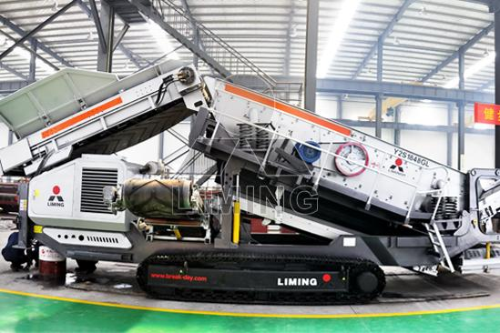
Highlights:
(1) Large hopper, with variable speed belt feeder, heavy-duty roller bed and heavy- duty belting.
(2) Unique Exotic design spreader plate to spread material across screen box.
(3) Optional Vibrating grid over feed hopper.
(4) Heavy duty tipping grid activated by remote control.
(5) Efficiency. Screening highly capability with processing strong parameters, technical advanced structure.
(6) The tracked vibrating screen adopts a cylinder-type eccentric shaft vibration exciter and partial block conditioning amplitude, which makes it easy to maintain.
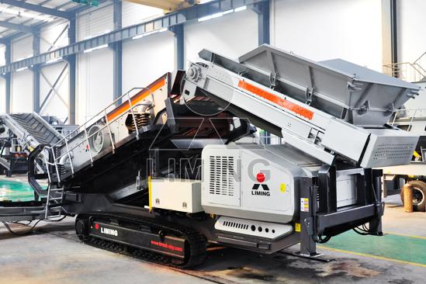
Working Principle:
Mobile Vibrating Screen moves round. It has multi-layers and is of high efficiency. The eccentric shaft vibration exciter and partial block help to adjust amplitude. The material drops down along the long line. In screen grading, the material is separated mechanically on screen plates. Rolling bearings in vibrating screens are stressed by high, mostly shock-type loads. Moreover, the bearings, while rotating about their own axis, perform a circular, elliptical or linear vibrating motion. This results in high radial accelerations which additionally stress the bearings, and especially the cages, considerably. The operating speeds are usually very high. As a result, the bearing temperatures are up to 20 to 30 degrees Kelvin higher than in normal applications. In addition, considerable misalignments between the bearing locations and considerable shaft deflections have to be accommodated.
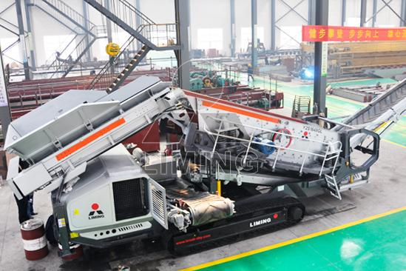
Technical Data:
Vibrating Feeder | GZD-960X3800 | GZD-960X3800 | GZD-960X3800
Impact Crusher | PF1010 | PF1210 | PF1214
Main Belt Width (mm) | 800 | 800 | 1000
Main Belt Discharge Height (mm) | 2700 | 2700 | 2700
Side Belt Width (mm) | 500 | 500 | 500
Side Belt Discharge Height (mm) | 2700 | 2700 | 2700
Power (KW) | 150KW | 200 | 300
Transportation Length (mm) | 12000 | 13000 | 13000
Transportation Width (mm) | 3050 | 3050 | 3050
Transportation Height (mm) | 3500 | 3800 | 3800
Transportation Weight (T) | 36 | 42 | 48
Contact Us:
Thank you for your interest in Liming Heavy Industry (Shanghai). Please feel free to use any of the methods below to get in touch with us.
Office Tel: 0086-21-33901608
Fax: 0086-21-58377628
Email: sales@shcrusher.com
MSN Online: shcrusher@hotmail.com
Address: No.201-34, Huaxia 3rd Road, Pudong New Area, Shanghai, China.
Postcode: 201200

For more detailed information, please click here: http://www.shanghai-crusher.com/

