Tracked Jaw Crusher

Brief Introduction:
The tracked Mobile Jaw Crusher and also called crawler jaw crusher or pedrail jaw crusher was designed by us, utilizing the very latest European technology, including finite element techniques to minimize stress levels within the frame itself. The Mobile Jaw Crusher is a track-mounted plant featuring unique automatic blockage clearance and tramp iron relief capabilities unequaled in our industry. Operated by wireless remote control, the Mobile Jaw Crusher can process your hardest and most difficult materials, greatly reducing the typical risk of stoppages, damages and high maintenance costs associated with most other jaw crushers. This powerful high capacity plant will crush your competition.
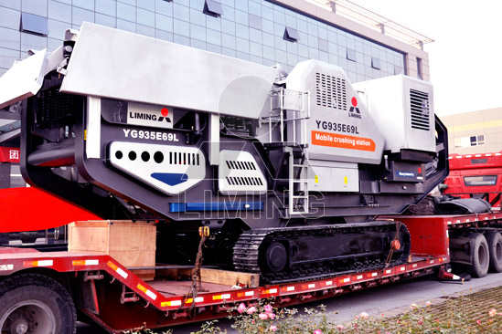

Highlights:
Tracked jaw crusher designed for rock and recycle applications, Fast Tracked jaw crusher offer the ultimate in portability. You simply drive off of a lowboy trailer and immediately begin crushing up to 400 t/h. Features like a large heavy duty hopper, hand held remote controls and a sturdy Vanguard Jaw Crusher ensure you ease of operation coupled with reliable production.
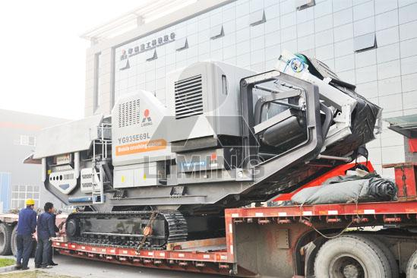

Working Principle:
Tracked jaw crusher designed for rock and recycle applications, Fast Tracked jaw crusher offer the ultimate in portability. You simply drive off of a lowboy trailer and immediately begin crushing up to 400 t/h. Features like a large heavy duty hopper, hand held remote controls and a sturdy Vanguard Jaw Crusher ensure you ease of operation coupled with reliable production.

Technical Data:
Vibrating Feeder | GZD-960X3800 | GZD-960X3800 | GZD-960X3800
Jaw Crusher | PE600X900 | PE750X1060 | PE500X750
Main Belt Width (mm) | 800 | 1000 | 650
Main Belt Discharge Height (mm) | 2700 | 2800 | 2700
Side Belt Width (mm) | 500 | 650 | 500
Side Belt Discharge Height (mm) | 2700 | 2900 | 2700
Power (KW) | 150 | 220 | 150
Transportation Length (mm) | 13000 | 14000 | 12500
Transportation Width (mm) | 3050 | 3180 | 3050
Transportation Height (mm) | 3500 | 4300 | 3400
Transportation Weight (T) | 39 | 54 | 33

Contact Us:
Thank you for your interest in Liming Heavy Industry (Shanghai). Please feel free to use any of the methods below to get in touch with us.
Office Tel: 0086-21-33901608
Fax: 0086-21-58377628
Email: sales@shcrusher.com
MSN Online: shcrusher@hotmail.com
Address: No.201-34, Huaxia 3rd Road, Pudong New Area, Shanghai, China.
Postcode: 201200

For more detailed information, please click here: http://www.shanghai-crusher.com/

