Tracked Impact Crusher

Brief Introduction:

The tracked Mobile Impact Crusher (also called crawler mobile impact crusher or pedrail mobile impact crusher) is powered by a fuel-efficient compliant diesel engine. The Mobile Impact Crusher is the star product of Liming Heavy Industry. Mobile Impact Crusher is manufactured with the latest manufacturing technology, using the high-quality and high-chromium plate hammer and wear-resistance impact lining plate. The large crushing ratio plus the impact crusher’s inherent characters, which can produce final products with good-quality particle shape, contribute to making the mobile crushing unit have a wider application range.

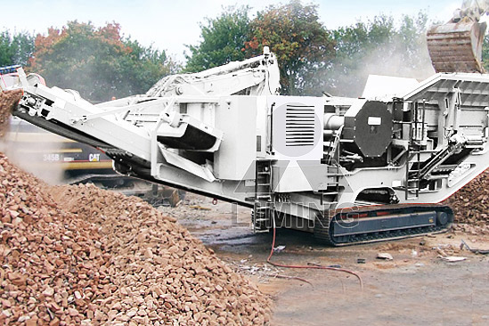

Highlights:
(1) Integrated machine set with the impact crusher series mobile crusher.
(2) This mobile impact crusher is designed to be of high flexibility.
(3) Lower transportation cost our customs will pay.
(4) High efficiency.
(5) The mobile impact crusher is easy to adjust and to collocate.
(6) Reliable performance and convenient maintenance.

Working Principle:
Mobile impact crusher is a new designed mobile crushing & screening plant, which is flexible, convenient and strong in mobility, so this series mobile crusher can save a large construction capital and relocation. Raw Materials can be broken by the impact crusher and other crushing equipment of the mobile crushing plant at the locale without being transported again and also can be moved with the promotional exploitation of the raw material, which saves a large number of transportation costs.
The Mobile Impact Crusher (mobile crushing and screening plants) is composed of primary crushing and screening station and secondary one, belt conveyor, etc. Every mobile crusher station is an independent working unit, they can respectively assume their different responsibility, and the belt conveyer is responsible for material transmitting and piling up between each mobile crusher station.

Technical Data:
Vibrating Feeder | GZD-960X3800 | GZD-960X3800 | GZD-960X3800
Impact Crusher | PF1010 | PF1210 | PF1214
Main Belt Width (mm) | 800 | 800 | 1000
Main Belt Discharge Height (mm) | 2700 | 2700 | 2700
Side Belt Width (mm) | 500 | 500 | 500
Side Belt Discharge Height (mm) | 2700 | 2700 | 2700
Power (KW) | 150KW | 200 | 300
Transportation Length (mm) | 12000 | 13000 | 13000
Transportation Width (mm) | 3050 | 3050 | 3050
Transportation Height (mm) | 3500 | 3800 | 3800
Transportation Weight (T) | 36 | 42 | 48

Contact Us:
Thank you for your interest in Liming Heavy Industry (Shanghai). Please feel free to use any of the methods below to get in touch with us.
Office Tel: 0086-21-33901608
Fax: 0086-21-58377628
Email: sales@shcrusher.com
MSN Online: shcrusher@hotmail.com
Address: No.201-34, Huaxia 3rd Road, Pudong New Area, Shanghai, China.
Postcode: 201200

For more detailed information, please click here: http://www.shanghai-crusher.com/

