Tracked Cone Crusher
Brief Introduction:
Mobile Cone Crushing plant (also named YSY Series Fine Mobile Cone Crushing plant) manufactured by Liming Heavy Industry introduced new products, is new rock crushing equipment. Mobile Cone Crushing plant is mainly used in the field of fine crushing operations, according to different stone and finished product use in stone materials production operations, instead of impact crusher to produce higher hardness and more fine-grained stone materials products, the configuration of the cone crusher can be adjusted according to actual needs of different crushing cavity, expanding the fields and scope of YSY Middle Mobile Cone Crushing plant.
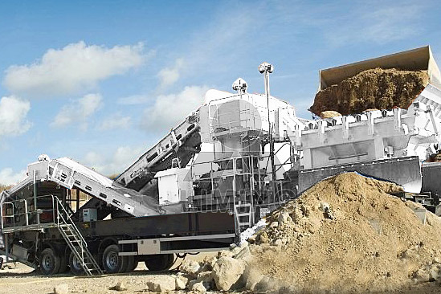
Highlights:
Mobile Cone Crushing plant is developed based on different crushing principles and crushing effect of cone crusher and impact crusher, and the feed requirements and the expected size are very different, and as mobile crushing plant in terms of ease of operation, it has the common advantage of YGE series mobile crushing plant and YSF series mobile crushing plant.
(1) Unit and equipment installation integration, the whole coordination strong, layout reasonable and compact, these save time and space for site operation, increase flexibility, while eliminating a lot of space infrastructure, greatly reducing the investment costs.
(2) The unit trailer chassis is higher, the body width is less than operation semi-trailer, and turning radius is small, easy to drive under the environment of rugged poor road in the broken ground.
(3) Cone crusher configured not only has the function of fine crushing, but also directly output mid-fine granularity finished, fully functional, which directly reduces the cost of shipping materials. In addition, longer units can directly transfer the broken material into the Transport carriages, to facilitate the timely transportation.
(4) Cone crusher adopts static pressure principle, by the second vibration isolation, equipment vibration is little, more conducive to the implementation of the installation.
(5) The material layer of cone crusher has more efficient, and job stability, also saves much time to a great extent.
(6) Equipment configures flexibility, can be stand-alone group to produce independently, and also be composed of coarse crushing equipment associated with the operation. The diesel generator in unit not only supplies the power to unit, but also supplies targeted power to process system configuration unit, greatly improving the adaptability of the equipment.
(7) Technology is mature, operation and maintenance is easy. Unit configured devices are clear in division, concise, easy to maintain.
Working Principle:
When working, material can directly into the cone crusher to the ideal size, circular vibrating screen can screen out products with different specifications of stone materials, and belt conveyer output stacking or transport. As the models of mobile crushing plant using a new high efficient cone crusher, it can make the material processing and crushing in one step, the product shape evenly, greatly improving efficiency.
Technical Data:
Cone Crusher | CS75 | CS160 | HP220
Vibrating Feeder | GLD1500/4 | GLD1500/5 | GLD1500/5
Up Hopper Volume (M³) | 4 | 5 | 5
Feeding Height (mm) | 2700 | 2900 | 2900
Main Belt Width (mm) | 800 | 1000 | 1000
Main Belt Discharge Height (mm) | 2700 | 2800 | 2800
Power (KW) | 150KW | 300KW | 400KW
Transportation Length (mm) | 12000 | 12500 | 12500
Transportation Width (mm) | 3050 | 3050 | 3050
Transportation Height (mm) | 3700 | 3900 | 3900
Transportation Weight (T) | 38 | 45 | 50
Contact Us:
Thank you for your interest in Liming Heavy Industry (Shanghai). Please feel free to use any of the methods below to get in touch with us.
Office Tel: 0086-21-33901608
Fax: 0086-21-58377628
Email: sales@shcrusher.com
MSN Online: shcrusher@hotmail.com
Address: No.201-34, Huaxia 3rd Road, Pudong New Area, Shanghai, China.
Postcode: 201200

For more detailed information, please click here: http://www.shanghai-crusher.com/

