Product

Brief Introduction:

TGM Super Pressure Trapezium Mill, with the patent number of ZL 200520030288.3, has passed the quality certification and CE certification, featured by the original design, reasonable structure, small area covered, low power consumption, long service time, cheap wearing parts and high price-performance ratio, etc. Each item of technical performance has reached the world advanced level. Compared with the traditional mill, its superiorities are beyond comparison.

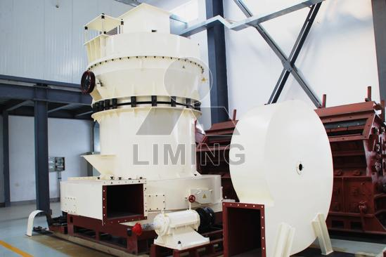

Highlights:

(1) The innovative design of the mill roller and grinding ring. Compared with Raymond mill, the mill roller and grinding ring are designed in multi-stairs shape, which can reduce the speed of the material gliding between the trapezium mill roller and the grinding ring, increase the time of the material being grinded, and improve the fineness and output of the finished product.

(2) Effective balanced and loaded spring. The trapezium grinding mill absorbs the merits of the Raymond mill and the suspension mill. The grinding roller assembly is connected with the horizontal spring through the pull-rod, producing the radial force which can avoid the wear and tear due to the large block of material entering into the grinding chamber, thus prolongs the service life of the equipment.

(3) The host machine and the power classifier are connected flexibly, and the damping spring and the seal tape not only reduce the vibration and noise, but also avoid the resonance.

(4) High-density and high-precision impeller device.

(5) High-efficiency and energy-saving centrifugal induced draft fan. The fan plays an important role in the whole operation process of the mill. The trapezium grinding mill adopts the high-efficiency and energy-saving fan, and the efficiency is improved greatly compared with the straight-blade fan.

(6) Compared with Raymond mill, the patented product-super pressure trapezium grinding mill makes it easy and quick to adjust the clearance between the ends of the powder classifier and the shell, and improves the precision of the finished product.

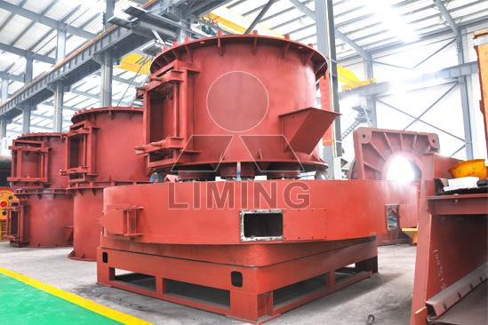

Working Principle:

The mainframe is driven by the speed reducer through the central axis in the mill. The quincunx stand connected with the upper part of central axis, at the quincunx stand and rollers there is shovel system. Materials are fed into the space between rollers and shovels when they are turning, and then be grinded by the pressure produced when rollers are turning, thus powder is made.

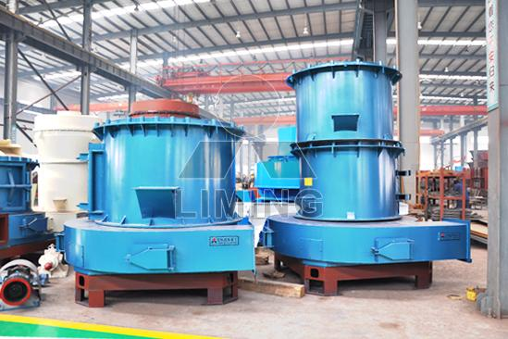

Technical Data:
Table 1
Item\Model | TGM100 | TGM130 | TGM160
Roller piece | 4 | 5 | 6
Roller Diameter×Height(mm) | Ф320×200 | Ф400x240 | Ф440×270
Ring Inner Diameter×Height(mm) | Ф980×200 | Ф1280×240 | Ф1600×270
Speed Of Main frame (r/min) | 130 | 98 | 82
Max. Input Size (mm) | 25 | 30 | 35
Product Size (mm) | 1.6～0.045  fineness can reach to 0.038 | 1.6～0.045  fineness can reach to 0.038 | 1.6～0.045  fineness can reach to 0.038
Capacity (t/h) | 3～8.8 | 6～13 | 13～22
Overall Dimension (mm) | 9910×5365×8310 | 7910×7000×9645 | 12550×5700×8355
Weight (t) | 16 | 26.1 | 35
Note:
1. Based upon limestone grinding with 80% pass-through;
2. The final technical data are subject to the operation manual along with the machine.
Table 2
Name | Item | Unit | Specifications & Technical Data
Name | Item | Unit | TGM100 | TGM130 | TGM160
Motor for main frame | Model |  | Y225S-4 | Y280S-4 | Y315M1-4
Motor for main frame | Power | kW | 37 | 75 | 132
Motor for main frame | Rev. | rpm | 1480 | 1480 | 1480
Motor for separator | Model |  | YCT200-4A | YCT200-4B | YCT205-4A
Motor for separator | Power | kW | 5.5 | 7.5 | 18.5
Motor for separator | Rev | rpm | 125～1250 | 125～1250 | 125～1250
Motor for Elevator | Model |  | Y100L-4 | Y100L-4 | Y112M-4
Motor for Elevator | Power | kW | 3 | 3 | 4
Motor for Elevator | Rev | rpm | 1420 | 1420 | 1420
Motor for Blower | Model |  | Y225S-4 | Y280S-4 | Y315M1-4
Motor for Blower | Power | kW | 37 | 75 | 132
Motor for Blower | REV | rpm | 1480 | 1480 | 1480
Motor for Jaw Crusher | Model | PE | 250×400 | 250×400 | 250×100
Motor for Jaw Crusher | Model | PE | Y180L-6 | Y180L-6 | Y200M-6
Motor for Jaw Crusher | Power | KW | 15 | 15 | 30
Motor for Jaw Crusher | REV | rpm | 970 | 970 | 970
Electro-Magnetic Vibrating Feeder | Model |  | GZ2F | GZ2F | GZ3F
Electro-Magnetic Vibrating Feeder | Power | W | 150 | 150 | 200

Contact Us:
Thank you for your interest in Liming Heavy Industry (Shanghai). Please feel free to use any of the methods below to get in touch with us.
Office Tel: 0086-21-33901608
Fax: 0086-21-58377628
Email: sales@shcrusher.com
MSN Online: shcrusher@hotmail.com
Address: No.201-34, Huaxia 3rd Road, Pudong New Area, Shanghai, China.
Postcode: 201200

For more detailed information, please click here:
http://www.shanghai-crusher.com/

