Product

Brief Introduction:

Generally speaking, one complete set of Stone Crushing Line should include: vibrating feeder, fist degree crushing equipments, second degree crushing equipments, vibrating screen, conveyor belt, and electric control panel and so on. Reshaping machine will be added if necessary.

First degree crushing equipment is usually jaw crusher called as primary crusher; secondary crushing equipment is cone crusher, impact crusher and so on; vibrating screen sieves the mixture comes from crushers into several sizes according to the needs. Layers of vibrating screen decide varieties of the final products and screen mesh decides size of the final products. Reshaping equipment is mainly used in the industry which has a higher requirement to the final products, like highway. Reshaping equipment will eliminate acicular and flake like products to make the final products even granular of cubic shapes with higher degree of strength.

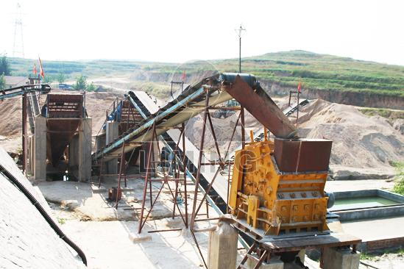

Highlights:

The whole line (Stone Crushing Line) is highly automatic and the size of the finished products is even, good-shaped and can be adjustable, with high crushing ratio, low power consumption and high capacity, which are suitable for big, middle and small projects, such as road and bridge construction.

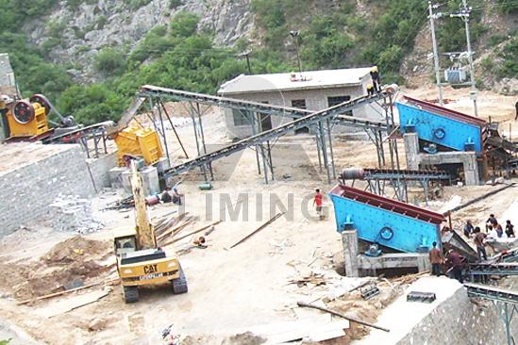

Working Principle:

Big size stones are transferred to primary crusher through vibrating feeder from hopper for first crushing, and then the crushed materials are transferred to impact crusher through belt conveyor for secondary crushing. The materials crushed will be transferred to the vibrating screen, and separated to different sizes. The aggregate with suitable size will be transferred to the final product pile and aggregate with unsuitable size will be transferred to the impact crusher for re-crushing. Thus forms a closed and manifold cycles. The sizes of final products will be graded and separated according to customers' requirements, and the duster will be attached for the sake of environment protection.

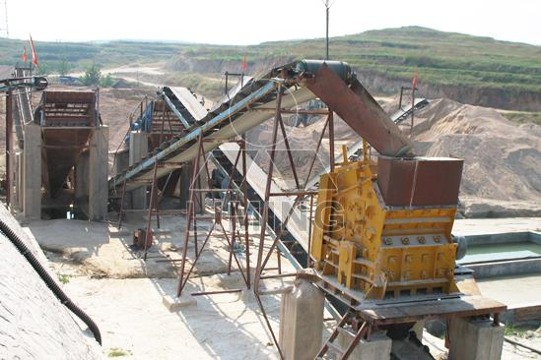

Technical Data:

Belt conveyer + jaw crusher + vibrating screen + impact crusher + belt conveyer

Technical parameters can refer to belt conveyer, jaw crusher, vibrating screen, impact crusher.
Contact Us:
Thank you for your interest in Liming Heavy Industry (Shanghai). Please feel free to use any of the methods below to get in touch with us.
Office Tel: 0086-21-33901608
Fax: 0086-21-58377628
Email: sales@shcrusher.com
MSN Online: shcrusher@hotmail.com
Address: No.201-34, Huaxia 3rd Road, Pudong New Area, Shanghai, China.
Postcode: 201200

For more detailed information, please click here:
http://www.shanghai-crusher.com/

