Spring Cone Crusher
Brief Introduction:
Spring Cone crusher is suitable to crush various kinds of ores and rocks of medium or above medium hardness. The spring cone crusher acts as an overloading protection system that allows metal to pass through the crushing chamber so as not to damage the cone crusher. The type of crushing chamber depends upon size of feeding and fineness of crushed product. The standard type (PYB) is applied to medium crushing, the medium type is applied to medium or fine crushing and the short head type is applied to fine crushing.
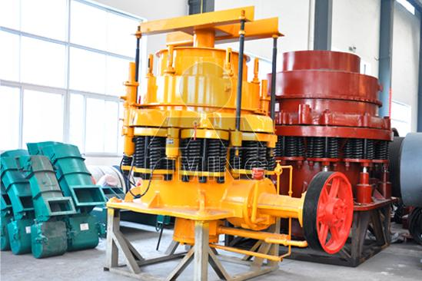
Highlights:
(1) High efficiency; high crushing capacity;
(2) Low operation and maintenance cost, easy to adjust;
(3) As spare parts selection and structural design is reasonable, the lifespan will be longer;
(4) Reducing downtime;
(5) Different types of crushing chambers to satisfy different customers’ needs.
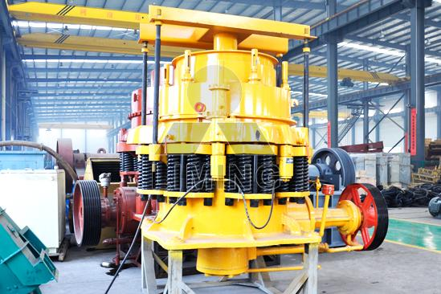
Working Principle:
Cone crusher crushes materials by the working surface between the movable cone and fixed cone. So it is more advanced and efficiency efficient than jaw crusher. The movable cone is supported by spherical bearing and fixed on a hanging erect shaft which is set in the eccentric sleeve, and the sleeve is set on the stopping and pushing bearing. The movable cone and erect shaft are driven by the eccentric shaft sleeve together. The eccentric shaft sleeve is driven by horizontal shaft and imbricate gear, and the wheel of the conveyor belt is driven by motor through v-belts. The lower part of vertical shaft is installed in the eccentric sleeve. When the eccentric sleeve rotates, there is a conical surface lined out by the shaft. When the movable cone comes near the fixed cone, rocks are grinded into pieces, when the movable cone leaves, grinded materials is discharged from the discharge hole. The fixed cone can be ascended or descended by adjusting setting to adjust the width of discharge hole, consequently the output size is determined adjusted.
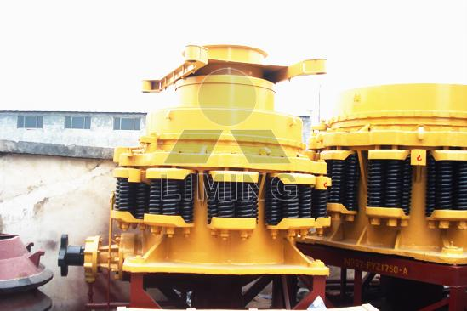
Technical Data:
Type |  | Max. input (mm) | Adjusting range of output (mm) | Capacity (t/h) | Motor power (kW) | weight (t) | Overall dimensions (L×W×H)(mm)
PYB | 600 | 65 | 12-25 | 12-25 | 30 | 5 | 2800×1300×1700
PYD | 600 | 35 | 3-15 | 5-23 | 30 | 5.5 | 2800×1300×1700
PYB | 900 | 115 | 15-50 | 50-90 | 55 | 10.2 | 3050×1640×2350
PYZ | 900 | 60 | 5-20 | 20-65 | 55 | 10.2 | 3050×1640×2350
PYD | 900 | 40 | 3-13 | 15-50 | 55 | 10.3 | 3050×1640×2350
PYB | 1200 | 145 | 20-50 | 110-200 | 110 | 24.7 | 4152×2300×2980
PYZ | 1200 | 100 | 8-26 | 50-150 | 110 | 25 | 4152×2300×2980
PYD | 1200 | 50 | 3-15 | 18-105 | 110 | 25.6 | 4152×2300×2980
PYB | 1750 | 215 | 25-60 | 280-480 | 160 | 50.3 | 4870×3800×4192
PYZ | 1750 | 185 | 10-30 | 115-320 | 160 | 50.3 | 4870×3800×4192
PYD | 1750 | 85 | 5-15 | 75-230 | 160 | 50.4 | 4870×3800×4192
PYB | 2200 | 300 | 30-60 | 590-1000 | 260-280 | 80 | 7705×3430×4852
PYZ | 2200 | 230 | 10-30 | 200-580 | 260-280 | 80 | 7705×3430×4852
PYD | 2200 | 100 | 5-15 | 120-340 | 260-280 | 81.4 | 7705×3430×4852

Contact Us:
Thank you for your interest in Liming Heavy Industry (Shanghai). Please feel free to use any of the methods below to get in touch with us.
Office Tel: 0086-21-33901608
Fax: 0086-21-58377628
Email: sales@shcrusher.com
MSN Online: shcrusher@hotmail.com
Address: No.201-34, Huaxia 3rd Road, Pudong New Area, Shanghai, China.
Postcode: 201200

For more detailed information, please click here: http://www.shanghai-crusher.com/

