Product

Brief Introduction:

The XSD sand washing machine is widely used in the construction site, sand stone factory, the construction site of concrete dam of a hydropower station, concrete pre-cast parts factory, oil-well refilling and other industries. The original sealed structure and the reliable transmission device ensure the good dewatering effect after washing. Therefore, it’s an efficient sand washing equipment used together with the sand making machine. This series washing machine is arranged with a slant angle of 15°. The section under the water sink is surrounded by three weir plates, forming a sedimentation tank. The spiral head part is merged in the sedimentation tank, and it rotates continuously due to the motor driven by the speed reducer, and is supplied with washing water by the perforated plates at the bottom of the sedimentation tank. This equipment has three functions as washing, dewatering and classifying.

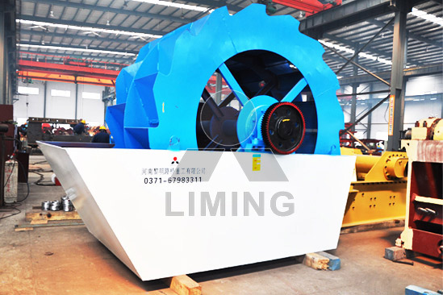

Highlights:

(1)This type of sand washing machine has a simple structure, stable performance, high cleanliness, and little sand loss in the washing process, especially, the transmission part of the sand washing machine is isolated from the water and sand, so, its failure rate is much lower than the current common sand washing machine and the service life is long.

(2)The structure is reasonable; the original seal structure, full-closed oil-bath type transmission device and adjustable weir plate, enable this series product being efficient, durable, with a good cleaning and dewatering effect. In addition, they also contribute to keep the fine product stable.

(3)Large processing capability and low power consumption;

(4)Water-saving, without any pollution;

(5) Easy to maintain.

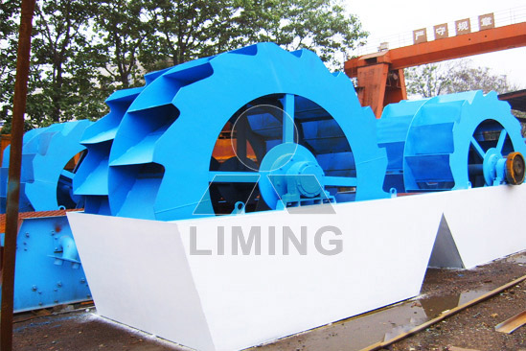

Working Principle:

The electric motor runs slowly with the impellor after decelerated by the belt, decelerator and gears wheel. The sand and stone flow into washing launder from feeding launder, rolls with the impellor, and grinds each other. The impurity covering the sand is washing away. At the same time, add more water, the strong water flow will take away waste and some low-weight wastes from washing launder. Through the above process, the washing function is finished. The clean sand and stone is lift up by vane. When it goes up slowly, the water begins to drop through the mesh and fall back in the washing launder. On one hand, water is removed from the sand and stone; on the other hand, the water can be fully used. Finally, the sand and stone goes to the out launder from the rotary impellor to finish the washing task.

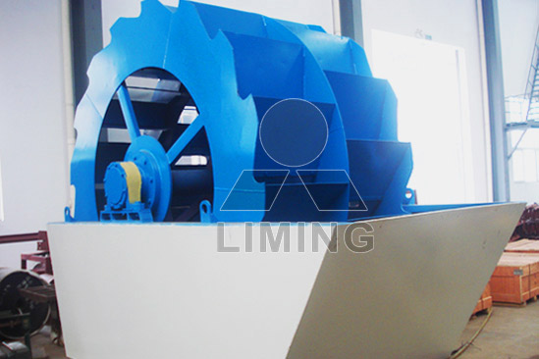

Technical Data:
Model | Wheel Size (mm) | Max feed size (mm) | Power (kW) | Weight (t) | Capacity (t/h) | Overall dimension (mm)
XSD2610 | Φ2600×1000 | 10 | 5.5 | 2.7 | 20-50 | 3255×1982×2690
XSD2816 | Φ2800×1600 | 10 | 11 | 5.5 | 30-60 | 3540×3000×2880
XSD3016 | Φ3000×1600 | 10 | 15 | 5.8 | 50-100 | 3845×3000×3080

Contact Us:
Thank you for your interest in Liming Heavy Industry (Shanghai). Please feel free to use any of the methods below to get in touch with us.
Office Tel: 0086-21-33901608
Fax: 0086-21-58377628
Email: sales@shcrusher.com
MSN Online: shcrusher@hotmail.com
Address: No.201-34, Huaxia 3rd Road, Pudong New Area, Shanghai, China.
Postcode: 201200

For more detailed information, please click here:
http://www.shanghai-crusher.com/

