Product

Brief Introduction:

Manufactured sands are mainly used in construction industry. The increasing insufficiencies of natural sands make manufactured sands more and more important. There is a wide range of raw materials to make manufactured sands, like common stone from mountains and pebbles from riverbed. Since our debut in the production of equipments for manufactured sands, our company makes research strictly adhering to sand standard in construction industry. Manufactured sand produced by equipments from our company has a superior quality compared with natural sand and is appreciated by customers.

Core equipment for manufactured sand production is impact crusher. There are three generations of impact crushers produced by our company and each generation has a superior performance and better economic benefits than its previous one. For impact crusher suitable feed size is required thus primary crushing and secondary crushing is necessary. Impact crusher has a high energy consumption and water is necessary for manufactured sand production, which the customer should keep in mind.

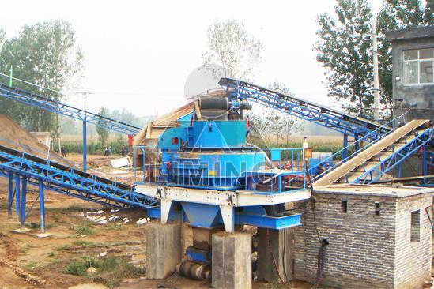

Highlights:

(1) This Sand Making Line has the characteristics of high automation, low operating cost, high crushing rate, high productivity, and little pollution, etc. It is energy saving and is convenient to maintain.

(2) Sand made by our Sand Making Line is of equal size, good shape and reasonable distribution, complying with national building sand standard.

(3) Due to reasonable matching of different levels of crushing machines and compact spatial arrangement, our crushing and screening plant has the features of small floor space, high economic efficiency. The crushed stones are of high quality, and the output rate of stone powder is low.

(4) Meanwhile, our Sand Making Line is equipped with electronic control system which ensures smooth discharging, reliable performance, high efficiency and energy conservation.

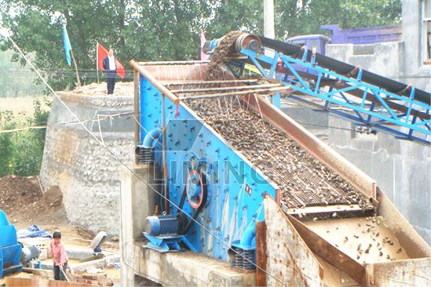

Working Principle:

The raw material is transferred to jaw crusher for primary crushing by vibrating feeder, then the crushed materials are transferred to sand-making machine through belt conveyor for secondary crushing. The materials crushed will be transferred to the vibrating screen. The materials with suitable size will be transferred to sand washing machine, after being washed, then clean final products will be discharged. The others with unsuitable size will be screened from vibrating screen, and then will be transferred to the sand-making machine, which forms a closed circuit manifold cycles. Sizes of final products will be according to our customers' requirements. If it is the dry process, the classifier and dedust equipment will be attached according to you requirement.

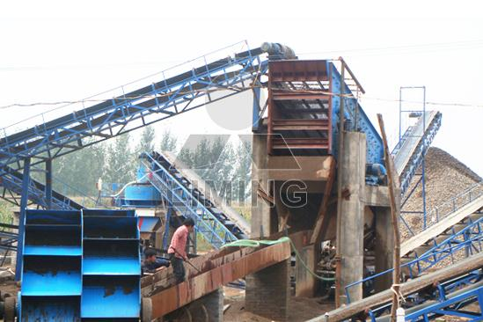

Technical Data:

Vibrating feeder + jaw crusher + pcl + cone crusher/ impcact crusher + vibrating screen + sand washing machine + belt conveyer

Technical parameter can refer to vibrating feeder, jaw crusher, pcl, cone crusher, impact crusher, vibrating screen, sand washing machine, belt conveyer.
Contact Us:
Thank you for your interest in Liming Heavy Industry (Shanghai). Please feel free to use any of the methods below to get in touch with us.
Office Tel: 0086-21-33901608
Fax: 0086-21-58377628
Email: sales@shcrusher.com
MSN Online: shcrusher@hotmail.com
Address: No.201-34, Huaxia 3rd Road, Pudong New Area, Shanghai, China.
Postcode: 201200

For more detailed information, please click here:
http://www.shanghai-crusher.com/

