Product

Brief Introduction:

Rotary Dryer is used to dry materials like limestone, slag, clay, etc. It can be used in building materials, metallurgy, chemical industry and cement industry. The dryer is mainly made up of rotary barrel, material lifting plate, transmission device, support device, seat ring, etc. The dryer has advantage of scientific structure, good craftsmanship, high capacity, low consumption and easy maintenance.

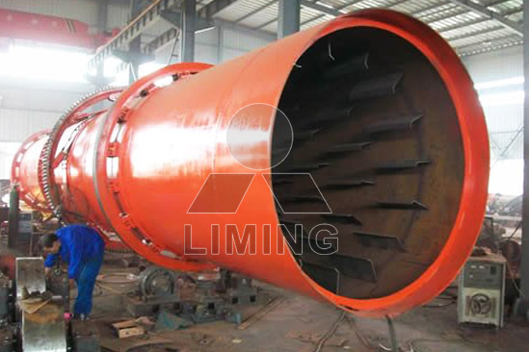

Highlights:

(1) It adopts X-type and H-type multi-segment material lifting plate.

(2) New type fluidized bed combustion boiler is suitable for various kinds of coal.

(3) Great improvement has been made on driven system of the dryer, teeth-changeable gear is used, by this maintenance is easier.

(4) The adoption of centralized control system enables automatic operation.

Working Principle:

Rotary dryer consist of a horizontally inclined rotating cylinder. Material is fed at one end and discharged at the other end. In direct-type rotary dryers, hot gases move through the cylinder in direct contact with the material, either with or against the direction of its flow. The cylinder is equipped with flights, which lift the material and shower it down through the hot gas stream.

Technical Data:
Model | Diameter of Barrel(mm) | Length of Barrel(m) | Gradient(°) | Rotary speed(RPM) | Power(Kw) | Volume(m³)
Φ0.6×8-12 | 600 | 8-12 | 3-5 | 8 | 4 | 2.26
Φ0.8×10-12 | 800 | 10-12 | 3-5 | 7.2 | 4 | 5.02
Φ1.0×10-12< | 1000 | 10-12 | 3-5 | 6.73 | 5.5 | 7.85
Φ1.2×12-18 | 1200 | 12-18 | 3-5 | 5.8 | 11-15 | 13.31
Φ1.5×12-18 | 1500 | 12-18 | 3-5 | 4.8 | 15-22 | 21.2
Φ1.8×12-18 | 1800 | 12-18 | 3-5 | 3.2 | 18.5-30 | 48.22
Φ2.2×12-22 | 2200 | 12-22 | 3-5 | 3 | 22-30 | 70.43
Φ2.8×15-24 | 2800 | 15-24 | 3-5 | 2.59 | 30-55 | 147.8

Notice: Any change of European Type Jaw Crusher technical data shall not be advised additionally.
Contact Us:
Thank you for your interest in Liming Heavy Industry (Shanghai). Please feel free to use any of the methods below to get in touch with us.
Office Tel: 0086-21-33901608
Fax: 0086-21-58377628
Email: sales@shcrusher.com
MSN Online: shcrusher@hotmail.com
Address: No.201-34, Huaxia 3rd Road, Pudong New Area, Shanghai, China.
Postcode: 201200

For more detailed information, please click here:
http://www.shanghai-crusher.com/

