Product

Brief Introduction:

Raymond mill (Raymond grinder)is featured by the advantages of high output, fine powder, continuous powder production with dry method, centralized particle size distribution, continuous and adjustable fineness, compact structure, low energy consumption, high efficiency, low power consumption, small covered area, little one-time investment, easy installation and maintenance as well as reliable operation etc. Raymond mill is applicable to the dry-type super-fine powder process of mineral materials. Therefore, it’s the ideal equipment for grinding industries, especially for small-size enterprises.

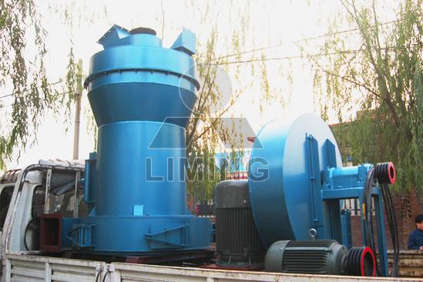

Highlights:

(1) The whole plant is a vertical structure of strong systematic characteristic, so it occupies small area. From crushing of raw material to grinding and packing is an independent production system.

(2) Compared with other milling plants, its passing ratio achieves 99%, this is what other mill cannot reach.

(3) Driving system of main frame adopts airtight gearing and pulley, drives smoothly and operates reliably.

(4) Main parts of the whole plant are made from cast and steel of high quality. The techniques is so subtly that insures the durability of whole plant.

(5) The electric control system is centralized controlled, so the automaticity is high, no people are needed in the operating room.

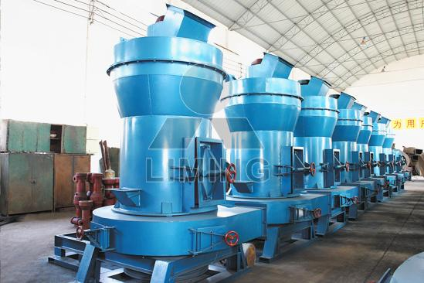

Working Principle:

The lump material will be conveyed into the storage bin by the bucket elevator after it is crushed into the required particle size by the jaw crusher. Then electro-vibrating feeder will uniformly transfer the material into the grinding chamber of the host machine. The material is up-thrown and fed into the space between the grinding roller and grinding ring in the process of synchronous rotation of the shovel and the grinding roller, and forms a cushion material layer. The material on this layer is grinded between the grinding roller and the grinding ring. Thus, the purpose of powder production is achieved. The grinded powder will be carried by the airflow of the fan into the analyzer for classification. The powder with the qualified fineness will enter the large cyclone collector, together with the airflow through the pipes, for classification, and then, will be discharged by the discharging device, as the finished product. The airflow is sucked into the air blower through the air-return pipe on the upper part of the large cyclone collector. The unqualified powder will be thrown to the external wall by the airflow and separated from the airflow. The coarse powder will fall into the grinding chamber for re-grinding due to its own gravity. The whole airflow system is closed and cyclic, and it flows under the positive and negative pressure circularly.

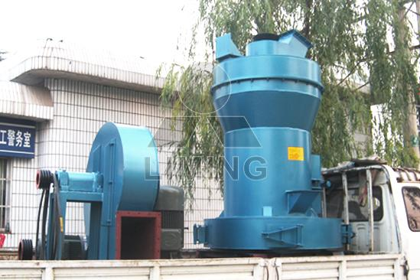

Technical Data:
Model |  |  | 3R2115 | 3R2615 | 3R2715 | 3R3016 | 4R3216
Roller | Number |  | 3 | 3 | 3 | 3 | 4
Roller | Diameter (mm) |  | 210 | 260 | 270 | 300 | 320
Roller | Height (mm) |  | 150 | 150 | 150 | 160 | 160
Ring | Inside diameter (mm) |  | 630 | 780 | 830 | 880 | 970
Ring | Height (mm) |  | 150 | 150 | 150 | 160 | 160
Maximum feed size (mm) |  |  | 15 | 15-20 | 15-20 | 15-20 | 20-25
Output size (mm) |  |  | 0.044-0.165 | 0.044-0.165 | 0.044-0.165 | 0.044-0.165 | 0.044-0.165
Power of main frame (kW) |  |  | 15 | 18.5 | 22 | 30 | 37
Fineness of final product (mm) | 0.165 | capacity (t/h) | 1.2-1.8 | 1.8-2.5 | 2.3-2.8 | 2.6-3.2 | 3.2-4.5
Fineness of final product (mm) | 0.075 | capacity (t/h) | 0.6-1.2 | 1.2-1.8 | 1.8-2.3 | 1.9-2.6 | 2.4-3.1
Fineness of final product (mm) | 0.044 | capacity (t/h) | 0.6-1.0 | 0.8-1.2 | 0.9-1.7 | 1-1.9 | 1.8-2.5

Contact Us:
Thank you for your interest in Liming Heavy Industry (Shanghai). Please feel free to use any of the methods below to get in touch with us.
Office Tel: 0086-21-33901608
Fax: 0086-21-58377628
Email: sales@shcrusher.com
MSN Online: shcrusher@hotmail.com
Address: No.201-34, Huaxia 3rd Road, Pudong New Area, Shanghai, China.
Postcode: 201200

For more detailed information, please click here:
http://www.shanghai-crusher.com/

