PE Series Jaw Crusher
Brief Introduction:
PE Series Jaw Crusher is mainly used for crushing various ores and large materials with compression strength not more than 320Mpa into medium-sized grains. Jaw crushers of our PE series are used as primary crusher and secondary crusher since they can achieve coarse crushing and fine crushing. It can process large stones with large capacity primarily and thus become the first choice for primary crushing. We have produced PE series jaw crusher based on many years of research and integrated with successful experience of the similar production at home and aboard.
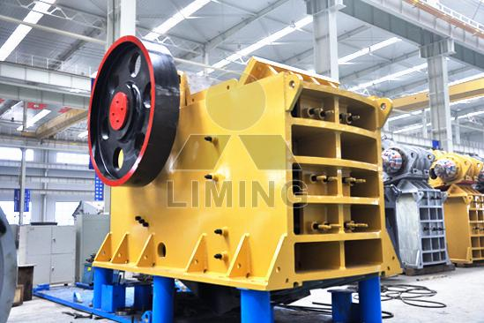
Highlights:
1. Deep crushing cavity and no dead area, which improves feeding capacity and output;
2. High reduction ratio and uniform final product size;
3. Spacing piece type discharge-hole adjustment device is reliable and convenient;
4. Reliable and safe lubrication system, convenient replacement of parts and small work load of maintenance;
5. Simple structure, operational reliability and low operation cost;
6. Energy-saving: single machine can save energy by 15% - 30%; the system can save energy by over 30% - 60%;
7. Large adjustment range of discharging hole can meet the demands of different users;
8. Low noise and little dust;
9. Simple structure, convenient maintenance and use; stable performance, low operation cost; high reduction ratio.
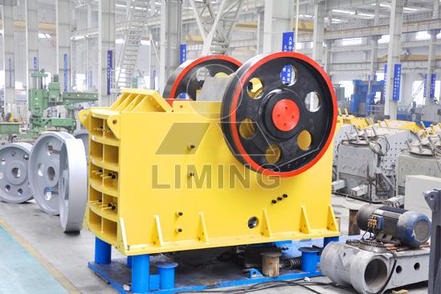
Working Principle:
The motor drives pulley and make the moving jaw doing periodic movement through eccentric shaft. The angle between toggle plate and movable jaw increases when the moving jaw moves up. Then the moving jaw is close to the fixed jaw. The stone is crushed in this process. The angle of jaw crusher between toggle plate and the moving jaw decreases when the moving jaw moves down, the moving jaw of jaw crusher moves away from fixed jaw by the pulling of rod and spring, the crushed stone is discharged from the outlet of jaw crusher.
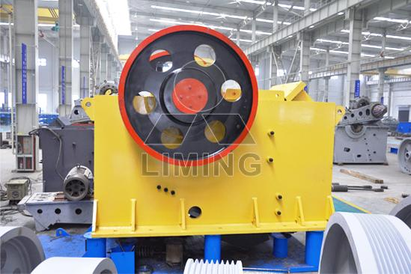
Technical Data:
Model | Max. Feeding Size (mm) | Discharge Size (mm) | Capacity (t/h) | Motor Power (kW) | Overall Dimensions (mm) | Weight (t)
PE150×250 | 125 | 10-40 | 1-3 | 5.5 | 896×745×935 | 0.8
PE250×400 | 200 | 20-60 | 5-20 | 15 | 1150×1275×1240 | 2.8
PE400×600 | 350 | 40-100 | 15-60 | 30 | 1700×1732×1653 | 6.5
PE500×750 | 425 | 50-100 | 50-100 | 55 | 2035×1921×2000 | 10.3
PE600×900 | 500 | 65-160 | 60-130 | 75 | 2290×2206×2370 | 16.5
PE750×1060 | 630 | 80-140 | 100-250 | 110 | 2620×2302×3110 | 29
PE900×1200 | 750 | 95-165 | 160-380 | 110 | 3789×2826×3025 | 54
PE1000×1200 | 850 | 195-265 | 315-550 | 110 | 3335×3182×3025 | 56
PE1200×1500 | 1020 | 150-300 | 300-800 | 160-220 | 4200×3750×3820 | 88
PEX250×1000 | 210 | 25-60 | 15-50 | 30 | 1550×1964×1380 | 6.5
Contact Us:
Thank you for your interest in Liming Heavy Industry (Shanghai). Please feel free to use any of the methods below to get in touch with us.
Office Tel: 0086-21-33901608
Fax: 0086-21-58377628
Email: sales@shcrusher.com
MSN Online: shcrusher@hotmail.com
Address: No.201-34, Huaxia 3rd Road, Pudong New Area, Shanghai, China.
Postcode: 201200

For more detailed information, please click here: http://www.shanghai-crusher.com/

