PCL Sand Making Machine
Brief Introduction:
PCL sand making machine is also called as PCL vertical shaft impact crusher, which is designed depending on years of hard work and study of mechanical mining equipment. PCL sand making machine plays an important role in crushing minerals into pieces. It is applicable to crushing and shaping for soft or medium-hard or extremely-hard materials and is widely used in all kinds of minerals, cement, refractory material, carborundum grain, glass raw material, construction sand, stone stock and all kinds of metallurgy slag.
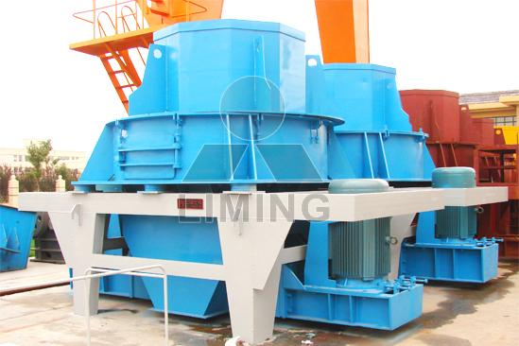
Highlights:
(1) Simple and reasonable structure and low operation cost.
(2) Have function such as secondary crushing and primary grinding small energy consumption, high output and high crushing rate.
(3) Small size of equipment, little friction of impeller self-lining, simple and convenient operation, convenient installation and operation.
(4) The influence of water content is very small; moisture content can reach about 8%.
(5) Have function of shaping; product is in cubic shape, with big stacking density and very little iron pollution.
(6) More applicable to crushing medium-hard and ultra hard material.
(7) Small quantity of easy wear part is made of ultra-hard wear-resistant material, which has small size, light weight, facilitating replacing parts.
(8) Operating noise is lower than 75db (db grade), with little dust pollution.
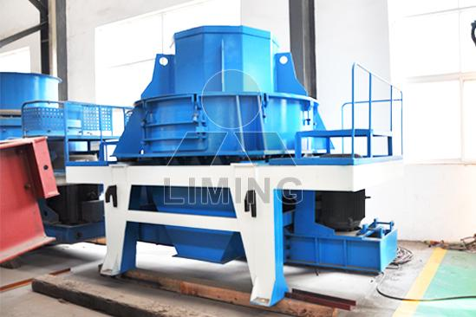
Working Principle:
Raw materials directly enter the high speed impeller from the top of the machine. With function of large centrifugal force, these materials impacts with the other materials falling around the rotor. Then they will impact with other materials inside the crushing chamber between impeller and frame, and finally being crushed.
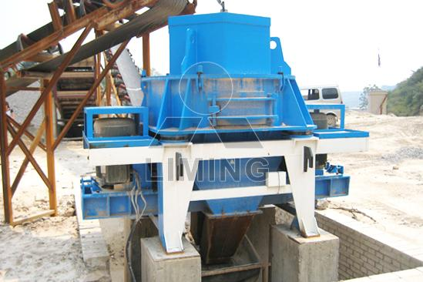
Technical Data:
Model | Rotate speed of impeller (r/min) | Max feed size (mm) | Power (kW) | Weight (including motor) (t) | Capacity (t/h) | Overall dimensions (mm)
PCL-600 | 2000-2600 | 30 | 2×30 | 5.6 | 10-30 | 2800×1550×2030
PCL-750 | 1600-2100 | 35 | 2×45 | 7.5 | 30-50 | 3300×1800×2440
PCL-900 | 1300-1700 | 40 | 2×55 | 12 | 50-80 | 3750×2120×2660
PCL-1050 | 1100-1450 | 45 | 2×110 | 16 | 70-120 | 4480×2450×2906
PCL-1250 | 950-1200 | 45 | 2×132 | 22 | 80-150 | 4563×2650×3176
PCL-1350 | 900-1200 | 50 | 2×160 | 26 | 120-200 | 5340×2940×3650
Contact Us:
Thank you for your interest in Liming Heavy Industry (Shanghai). Please feel free to use any of the methods below to get in touch with us.
Office Tel: 0086-21-33901608
Fax: 0086-21-58377628
Email: sales@shcrusher.com
MSN Online: shcrusher@hotmail.com
Address: No.201-34, Huaxia 3rd Road, Pudong New Area, Shanghai, China.
Postcode: 201200

For more detailed information, please click here: http://www.shanghai-crusher.com/

