Mobile Crushing and Screening
Brief Introduction:
Mobile Crushing and Screening is a new designed rock crushing & screening plant, which is flexible, convenient and strong in mobility, so it can save a large construction capital and relocation. Raw Materials can be broken at the local place without being transported again, and also can be moved with the further exploitation of the raw material, which saves a large number of transportation cost. Liming corporation specializes in producing crusher, screen, transportation, other rock breaking, and mineral processing equipment. On the basis of professional technology, we optimize and introduce two large and three small series of crushing and screening equipment. Each large series is divided into three series: rough, medium and fine crushing and screening mobile plant. Therefore, it can fully adapt to the various mobile crushing and screening spots, and creates more new business opportunities for customers while reducing cost of production.
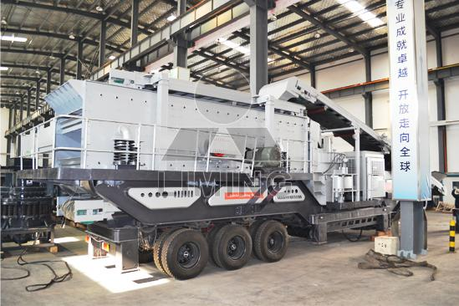
Highlights:
(1) Equipments Integration: Complete set of equipment, rational and compact combination, maximally saving the working area.
(2) High maneuverability: Small turning radius makes it convenient for driving on the ordinary road, and also easily for moving in and out of the mining area. Besides, it can be transferred to another working area anytime as needed, thus, eliminating the drawbacks compared with fixed crushing plant on dismounting, transporting and installation.
(3)Saving transportation cost of raw material: The mobile crushing plant can enter the mining area to work directly so that save the cost of the raw material being transported away from the mining area.
(4) Flexible configuration: According to different requirements of customers, we are providing a targeted mobile crushing plant configuration. It can operate with one single crushing station, and also can work with multiple crushing plants. That is can either crushing with one single plant and also composes multiply-stage crushing, screening and other plants work jointly.
(5) Independent power generation system: The mobile crushing plant can equip a generator accordingly so that can work normally in the non-power supply’s remote border district.
(6) Reliable quality and stable performance: With more than 20 years’ crushing equipments manufacture experience, facile, nimble, reasonable mobile frame, strict debugging before leaving the factory, ensuring every mobile crushing plant operate stably with reliable performance.
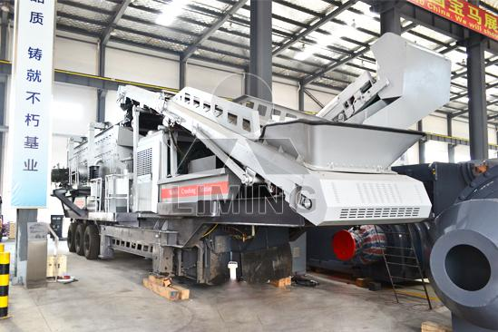
Working Principle:
The mobile crushing and screening plants is composed of primary crushing and screening station and secondary one, belt conveyor, etc. Every crushing station is an independent working unit, they can respectively assume their different responsibility, and the belt conveyer is responsible for material transmitting and piling up between each crushing station.
Technical Data:
TABLE 1
Cone Crusher | CS75 | CS160 | HP220
Vibrating Feeder | GLD1500/4 | GLD1500/5 | GLD1500/5
Up Hopper Volume (M³) | 4 | 5 | 5
Feeding Height (mm) | 2700 | 2900 | 2900
Main Belt Width (mm) | 800 | 1000 | 1000
Main Belt Discharge Height (mm) | 2700 | 2800 | 2800
Power (KW) | 150KW | 300KW | 400KW
Transportation Length (mm) | 12000 | 12500 | 12500
Transportation Width (mm) | 3050 | 3050 | 3050
Transportation Height (mm) | 3700 | 3900 | 3900
Transportation Weight (T) | 38 | 45 | 50
TABLE 2
Vibrating Screen | 2ZS1848 | 3YZS1860 | 3YZS2160
Closed hopper volume (M³) | 5 | 6 | 8
Closed hopper Height (mm) | 4300 | 5000 | 5000
Feeding Belt | B800X7.2 | B1000X8.5 | B1000X8.5
Screen Under Belt | B800X7 | B1000X8 | B1000X8
Screen Under Belt Discharge Height (mm) | 3500 | 3500 | 3500
Side Belt | B500X5 | B650X5 | B650X5
Side Belt Discharge Height (mm) | 3500 | 3500 | 3500
Front Belt | B650X7 | B800X8 | B800X8
Front Belt Discharge Height (mm) | 2800 | 3000 | 3000
Power (KW) | 120 | 150 | 180
Transportation Length (mm) | 12000 | 13500 | 1400
Transportation Width (mm) | 3050 | 3200 | 3400
Transportation Height (mm) | 3500 | 4100 | 4100
Transportation Weight (T) | 30 | 36 | 42
Contact Us:
Thank you for your interest in Liming Heavy Industry (Shanghai). Please feel free to use any of the methods below to get in touch with us.
Office Tel: 0086-21-33901608
Fax: 0086-21-58377628
Email: sales@shcrusher.com
MSN Online: shcrusher@hotmail.com
Address: No.201-34, Huaxia 3rd Road, Pudong New Area, Shanghai, China.
Postcode: 201200

For more detailed information, please click here: http://www.shanghai-crusher.com/

