Product

Brief Introduction:

Liming Heavy Industry supplies a full range of cost effective, heavy duty, fit for purpose, Mobile Crushing Line including jaw crushers, cone crushers, impact crushers, VSI crushers and double deck and triple deck horizontal and inclined vibrating screening equipment. Our Mobile Crushing Line are ideal for primary, secondary and tertiary crushing and screening applications in quarrying, mining, recycling, infrastructure and construction. Mobile Crushing Line is widely used in coal, aggregate, sand, construction and demolition (C&D) waste, mine ore, blasted rock and river gravel annually.

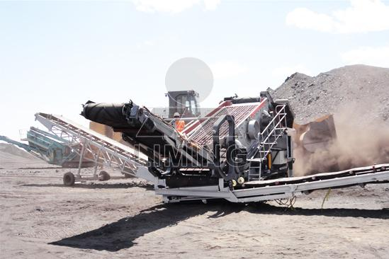

Highlights:

(1) World-level manufacturing technology is adopted, perfect raw material is selected.

(2) More advanced movable jaw assembly lengthens life of the mobile crushers. Movable jaw assembly, composed of high-quality cast steel structure, is driven by two big flying wheels which are also made from cast steel. Moreover, heavy eccentric axle is processed by forge mold. All of these make our mobile crusher extremely reliable.

(3) Integral cast steel structure is adopted for bearing seat. Integral cast steel bearing matches well with the crusher frame, at the same time, radial strength of the bearing seat is highly strengthened. However, the separate bearing seat does not have this advantage.

(4) Finite element analysis technology is adopted to make the crusher more efficient.

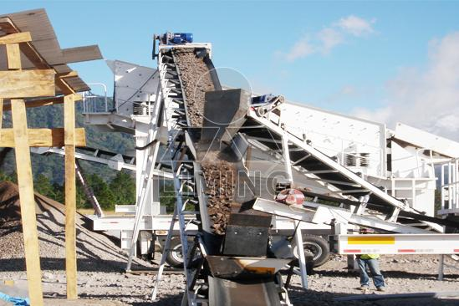

Working Principle:

Mobile Crushing Line is series machines for crushing various ore and construction aggregates, which have greatly expanded the working conception of primary and fine crushing. It's designed according to need of clients aiming at eliminating barriers of crushing site, environment, and complicate fundament equipment. According to different crushing process, procedure of "crushing first, screening later" or "screening first, crushing later" can be arranged. Crushing plants can be arranged as two-stage screening system of primary crushing and fine crushing. Meanwhile, three-stage screening system of coarse-mediate-fine crushing can also be arranges, which is superior in flexibility, can fit to various need of various clients. Mobile Crushing Line is classified according to requirements of clients as standard type and circulates type. Multiple combination types arranged according to requirements of top-end customers will be able to serve clients at every detailed levels.

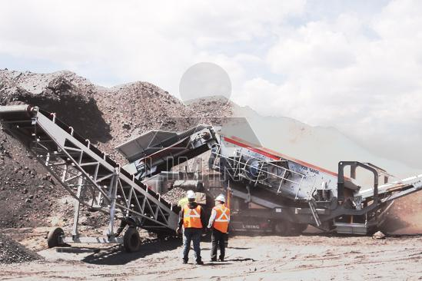

Technical Data:

Mobile crushing line can be equipped like this:

Primary crushing plant: vibrating feeder + jaw crusher.

Complete set of mobile crushing plant: vibrating feeder + jaw crusher + cone crusher/impact crusher + vibrating screen.

Technical parameter can refer to vibrating feeder, jaw crusher, cone crusher, impact crusher, vibrating screen.
Contact Us:
Thank you for your interest in Liming Heavy Industry (Shanghai). Please feel free to use any of the methods below to get in touch with us.
Office Tel: 0086-21-33901608
Fax: 0086-21-58377628
Email: sales@shcrusher.com
MSN Online: shcrusher@hotmail.com
Address: No.201-34, Huaxia 3rd Road, Pudong New Area, Shanghai, China.
Postcode: 201200

For more detailed information, please click here:
http://www.shanghai-crusher.com/

