Product

Brief Introduction:

Regarding to detailed condition, two kinds of techniques are usually adopted in producing manufactured sand, dry way and wet way. Both methods can produce high quality manufactured sand as concrete aggregate. Especially, the dry way can produce not only the manufactured sand used in road surface, but also the powder used in asphalt concrete.

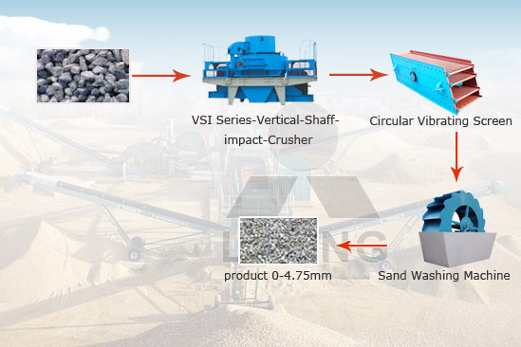

Highlights:

(1) Because of VSI Series Vertical Shaft Impact Crusher crushing principle, the shape of manufactured sand is cubic.

(2) The rank of manufactured sand is reasonable, and fineness modulus is adjustable.

(3) Index of manufactured sand is according to the standard of country, and the high quality of concrete aggregate.

Working Principle:

The flowchart of manufactured sand production line generally involves crushing, screening and possibly washing. The raw materials like granite, basalt, lime stone, sand stone, feldspar in the stockpile will be fed into primary jaw crusher for primary crushing, then conveyed to impact crusher for coarse crushing, according to the customer's demands, VSI crusher or multi deck vibrating screen will be needed to sizing the crushed rocks.

Technical Data:
Jaw crusher + vsi5x + circular vibrating screen + sand washing machine

Technical parameters can refer to jaw crusher, vsi5x, circular vibrating screen, sand washing machine.

Contact Us:
Thank you for your interest in Liming Heavy Industry (Shanghai). Please feel free to use any of the methods below to get in touch with us.
Office Tel: 0086-21-33901608
Fax: 0086-21-58377628
Email: sales@shcrusher.com
MSN Online: shcrusher@hotmail.com
Address: No.201-34, Huaxia 3rd Road, Pudong New Area, Shanghai, China.
Postcode: 201200

For more detailed information, please click here:
http://www.shanghai-crusher.com/

