Product

Brief Introduction:

MSB Coarse Powder Mill series is a kind of new high-tech milling machine to meet the requirements of sand processing customers. Based on our experts’ several years’ research experience in the milling industry and considering recommendations and requirements of domestic and foreign clients, it is the ideal equipment to replace Raymond Mill, mill, ball mill, and other traditional which only process power materials. It is high-efficiency equipment and widely applied in quartz sand, silica sand, foundry sand, fine sand and other sand abrasive industry. By being a component of closed production lines, it can produce various size products of better effect.

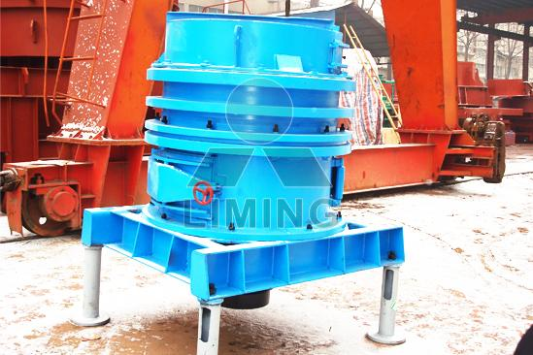

Highlights:

(1) High efficiency of wear material, wear evenly, the lifetime is three times higher than that of Raymond Mill.

(2) High percentage of sand can be produced by this machine.

(3) The device is a highly efficient desulfurization equipment of power plant. It can grind CaCO3 into fine power less than 1-2mm, the desulfurization effect is better.

(4) This machine can be used as pre-grind equipment before ball mill; the mall efficiency will increase 50%.

(5) Products out of this machine can be used to make firebrick, unburned brick, block and other new building materials.

(6) Mainly used for pre-processing of various crushable non-inflammable non-explosive brittle materials with Mohs hardness less than nine.

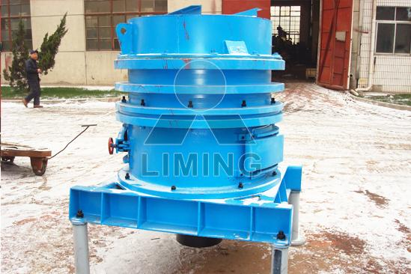

Working Principle:

Step with main shaft, bulk disk and roller bracket is driven by motor through reducer. Installed above bracket, roller assembly rotates with main shaft and swings freely meantime, this bring a large centrifugal force, which scatters bulk materials evenly in grinding intermediate layer between central roller and ring. The bulk materials are grinded into powder and fall on the bottom, and then discharged from discharging opening under the effect of synchronously-rotating scraper.

Technical Data:
Name | Parameter |  | Remark
Name | Model | Power | Remark
Model | MSB1004
Roller quantity | 4pcs
Max. feeding size | <30mm |  | Too hard material<20mm
Product size | 70-90%<2mm |  | Adjustable, check below
Capacity | 8-15ton/hour |  | Relative to average size and hardness of feeding material
Main motor power | 37-45kW |  | Use small motor if use fine material and want low capacity
Main motor model | Y2-225M-4 |  | 45 kW
Overall size（L×W×H） | 1.87×1.5×2.58(m） |  | Including main motor, decelerator and main unit
Largest single pc weight | 900kg
Total weight（excluding electricity control cabinet） | 8ton |  | Decelerator weight 1.7 ton
Jaw crusher of fine crushing | PEX150×750 | 15kW
Bucket elevator | TH250 | 3kW | Speed≥1.2m/s
Electromagnetic Vibrating feeder | GZ3 | 0.2kW | Distance between inlet and outlet 1000

Contact Us:
Thank you for your interest in Liming Heavy Industry (Shanghai). Please feel free to use any of the methods below to get in touch with us.
Office Tel: 0086-21-33901608
Fax: 0086-21-58377628
Email: sales@shcrusher.com
MSN Online: shcrusher@hotmail.com
Address: No.201-34, Huaxia 3rd Road, Pudong New Area, Shanghai, China.
Postcode: 201200

For more detailed information, please click here:
http://www.shanghai-crusher.com/

