Product

Brief Introduction:

Vertical mill is a type of milling equipment widely used in cement, chemical industry, coal and electricity industries, featured by a small size, low energy consumption, little noise, simple process and compact arrangement, etc, setting crushing, drying, milling and selecting in one. Therefore, it’s the preferred equipment for grinding and milling raw materials for a modern cement plant.

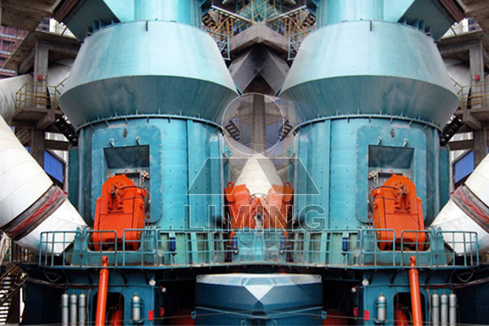

Highlights:

(1) Low Investment Cost. This mill itself can crush, dry, grinding, classifying, so the system is simple, and occupation area is about 50% of ball mill system. In addition, it can be installed outside, so it will reduce a large number of investment costs.

(2) Low Operation Cost. High efficiency: roller compacted materials directly onto the grinding disc, so power consumption is low. Compared with ball mill, it saves energy consumption by 30% ~ 40%. Less wear and tear: As the roller is not in direct contact with the disc, and material of the roller and liner is high quality, so life lime is long.

(3) High Drying Ability. As the hot air inside contacts directly with the material, drying ability is higher, and it saves energy. By regulating the air temperature, it can meet requirements with different humidity.

(4) Simple and reliable operation. It is equipped with automatic control systems, so remote control makes it easy to operate. It is equipped with one device, which prevents the roller from contacting with the liner directly, and avoids the destructive impact and severe vibration.

(5) The stability of product quality. As the material stays in the mill for a short time, it is easy to detect and control the product particle size and chemical composition, to reduce duplication of milling, stable product quality.

(6) Maintenance convenience. By repairing fuel tank, rotating the arm, it is fast to replace the roller sleeve, and liner, and reduce the downtime loss.

(7) Environmental protection. It is with small vibration, low noise, and the overall sealing. The system works under negative pressure, so there is no dust going out. It meets the requirements of the state Environmental Protection.

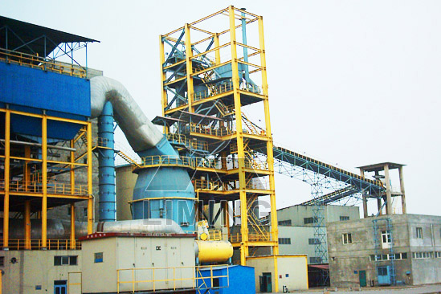

Working Principle:

Motor runs under the condition that speed reducer drives Nether millstone. The materials fall into the center of device through lock air feeder, and hot air comes into mill through air inlet under the function of centrifugal force, the materials when they come by the annular chute. The grinded materials will be taken up by air circulation and the bigger powder will fall down for regrinding. Qualified powders will be collected by collecting device as to be final product. Materials containing water will be dried when they contact with the hot air. Different humidify materials can be dried to the requirement through adjusting the temperature of hot air. Adjusting the separator can get the required fineness powders.

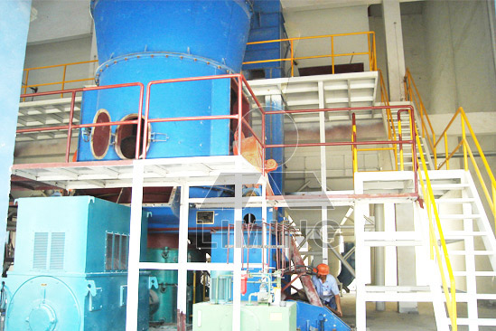

Technical Data:
Ore Mill
Contents|Data\Model |  | LM130K | LM150K | LM170K | LM190K | LM220K | LM240K
Disc Dia. (mm) |  | 1300 | 1500 | 1700 | 1900 | 2200 | 2400
Capacity (t/h) |  | 10~30 | 13~40 | 18~57 | 23~72 | 36~114 | 41~128
Output fineness | micron | 170~45 | 170~45 | 170~45 | 170~45 | 170~45 | 170~45
Output fineness | mesh | 80~325 | 80~325 | 80~325 | 80~325 | 80~325 | 80~325
Product moisture |  | ≤1% | ≤1% | ≤1% | ≤1% | ≤1% | ≤1%
Max.input size (mm) |  | <38 | <40 | <42 | <45 | <50 | <55
Best input moistrure |  | <4% | <4% | <4% | <4% | <4% | <4%
input moistrure(drying required) |  | <15% | <15% | <15% | <15% | <15% | <15%
Inlet air temperature (℃) |  | <350 | <350 | <350 | <350 | <350 | <350
Outlet air temperature (℃) |  | 70~95 | 70~95 | 70~95 | 70~95 | 70~95 | 70~95
Main mill power (KW) |  | 185~220 | 250~280 | 355~400 | 450~500 | 710~800 | 800~900
Dimension | Lmm | 3500 | 4200 | 4700 | 8500 | 10200 | 11700
Dimension | Wmm | 3400 | 3900 | 4500 | 5600 | 6700 | 7700
Dimension | Gmm | 5800 | 7100 | 8300 | 8800 | 10600 | 12200
Weight (t) |  | 48 | 75 | 90 | 100 | 125 | 160
Notes:
1. Material should be with hardness less than 7 in Mohs.
2. Hot air is only necessary if outlet moisture is required to be less than inlet moisture.
3.When grinding material that is difficult to grind, please use the largest power.
Coal Mill
Contents|Data\Model |  | LM130M | LM150M | LM170M | LM190M | LM220M | LM240M
Disc Dia. (mm) |  | 1300 | 1500 | 1700 | 1900 | 2200 | 2400
Capacity (t/h) |  | 10~15 | 16~22 | 20~28 | 26~35 | 35~45 | 40~50
fineness (R0.08) |  | <15% | <15% | <15% | <15% | <15% | <15%
Coal powder moisture |  | <1% | <1% | <1% | <1% | <1% | <1%
Max.input size (mm) |  | <38 | <40 | <42 | <45 | <50 | <55
input moistrure |  | <15% | <15% | <15% | <15% | <15% | <15%
Inlet air temperature (℃) |  | <350 | <350 | <350 | <350 | <350 | <350
Outlet air temperature (℃) |  | 75~95 | 75~95 | 75~95 | 75~95 | 75~95 | 75~95
Hardgrove index of raw coal (HGI) |  | >55 | >55 | >55 | >55 | >55 | >55
Main mill power (KW) |  | 185 | 250 | 315 | 400 | 500 | 560
Dimension | Lmm | 3500 | 4200 | 4700 | 8500 | 10200 | 11700
Dimension | Wmm | 3400 | 3900 | 4500 | 5600 | 6700 | 7700
Dimension | H mm | 5800 | 7100 | 8300 | 8800 | 10600 | 12200
Weight (t) |  | 46 | 75 | 94 | 100 | 122 | 157
Notice: Any change of LM Series Vertical Mill technical data shall not be advised additionally.

Contact Us:
Thank you for your interest in Liming Heavy Industry (Shanghai). Please feel free to use any of the methods below to get in touch with us.
Office Tel: 0086-21-33901608
Fax: 0086-21-58377628
Email: sales@shcrusher.com
MSN Online: shcrusher@hotmail.com
Address: No.201-34, Huaxia 3rd Road, Pudong New Area, Shanghai, China.
Postcode: 201200

For more detailed information, please click here:
http://www.shanghai-crusher.com/

