Hydraulic Cone Crusher
Brief Introduction:
Hydraulic cone crusher is developed as high-energy cone crusher by introducing German latest technology. The Hydraulic crusher does not only improve production capacity and crushing efficiency, but also expands application scope. As the latest generation product of substituting spring cone crusher and regenerating general hydraulic cone crusher in present mining and construction industry, it is the most ideal equipment for large-sized quarry and crushing of mining industry.
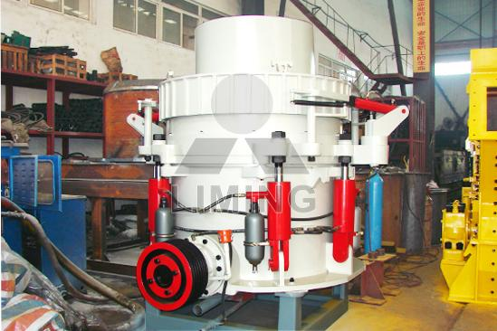
Highlights:
(1) With reasonable structure, advanced crushing principle and technical parameter, reliable operation, low operation cost, high crushing capacity, high production efficiency and high yield etc.
(2) Having convenient and reliable hydraulic system; able to provide safe and efficient overload protection.
(3) Many kinds of crushing cavities applicable to requirements on granularity for large range of products.
(4) Adopting hydraulic control and hydraulically cleaning cavity setting; greatly improving the degree of automation.
(5) Thin oil lubrication, reliable and advanced, improving service life.
Unique thin oil lubrication system design greatly improves the service life of equipments. There is no abrasion for non-contact type and high-performance sealing element, which improves reliability blocking dust and essentially eliminates common failures of original spring cone crusher such as oil water mixing.
(6) There are many kinds of shapes for crushing cavity with flexible application and strong applicability.
Only fixed cone liner and dynamic cone liner must be replaced for HPC cone crusher. The shapes of crushing cavity can be freely changed from standard ultra-large cavity shape to short-head ultra-thin cavity shape, to adapt to requirements of granularity for large range of products.
(7) Simple and convenient maintenance and operation
All parts of HPC cone crusher can be assembled and disassembled and maintained from the top part or the lateral side; the dynamic cone and the fixed cone are conveniently assembled and disassembled without needing to dismantle and assemble the frame and the binding bolt . Therefore, daily replacement of liner is more convenient for HP cone crusher. Use of hydraulic motor makes production efficiency of crusher better.
(8) It can provide higher production capacity and better grain shape of products and can be easily and automatically controlled. It has maximal reliability and flexibility, which can create more value for customers.
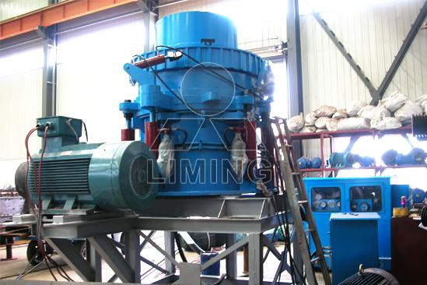
Working Principle:
The crushing principle of Hydraulic Cone Crusher is finished between fixed cone plate and movable cone plate. The cone crusher's motor drives the horizontal axis of the cone crusher through triangle belt and pulley, the horizontal axis drive the eccentric shaft bush to rotate through gear transmission. The eccentric shaft drives the main shaft to make the movable cone plate swing at a regulated track from time to time, the materials are crushed due to constant pressed and crooked in the crushing cavity. The finished products are discharged from the discharging opening.
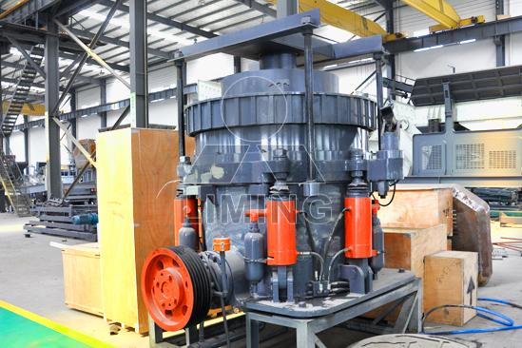
Technical Data:
Type | Cavity (coarse/fine) | Outlet adjustment range (mm) | Feed size (mm) | Capacity (t/h) | Power (kW) | Weight (t) | movable cone diameter (mm)
HPC-160 | C | 12-20 | 135 | 120-240 | 160 | 13 | 950
HPC-160 | F | 5-20 | 76 | 55-180 | 160 | 13 | 950
HPC-220 | C | 15-38 | 185 | 150-430 | 220 | 18.5 | 1160
HPC-220 | F | 6-25 | 110 | 90-260 | 220 | 18.5 | 1160
HPC-315 | C | 19-45 | 265 | 190-610 | 315 | 26 | 1400
HPC-315 | F | 9-30 | 150 | 108-320 | 315 | 26 | 1400
HPC-400 | C | 25-50 | 320 | 230-700 | 400 | 33 | 1500
Contact Us:
Thank you for your interest in Liming Heavy Industry (Shanghai). Please feel free to use any of the methods below to get in touch with us.
Office Tel: 0086-21-33901608
Fax: 0086-21-58377628
Email: sales@shcrusher.com
MSN Online: shcrusher@hotmail.com
Address: No.201-34, Huaxia 3rd Road, Pudong New Area, Shanghai, China.
Postcode: 201200

For more detailed information, please click here: http://www.shanghai-crusher.com/

