Hammer Crusher
Brief Introduction:
The hammer crusher is one of the main equipment for intermediate and fine crushing the brittle materials with less than intermediate such as limestone coal and other used in metallurgy, building material, chemical and water - power industry, with a feature of big crushing ratio and even product graininess.
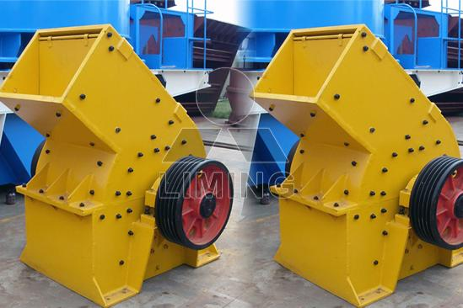
Highlights:
(1) Inlet large, high crushing chamber to meet the material hardness, fragmentation, the product powder less.
(2)Materials vacant, broken-power small.
(3) New hammer, big impact.
(4) Hammer shaft mounted adjustable hammer and long life.
(5) Raster size adjustable and controllable particle size, particle shape well.
(6)Chassis can be turned over to maintenance more convenient.
(7)Square shank, impact resistance, wear and tear.
(8)Compact, machine rigidity.
(9)Spell structure, handling, ease of installation.
(10)Shock, impact, impact (stone at stone) broken-function, high efficiency, engine wear is small, overall efficiency significantly.
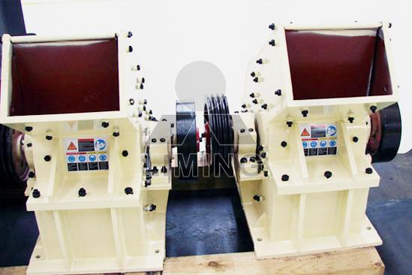
Working Principle:
In the hammer mill machine, the motor drives the rotor to rotate at a high speed through the belt, and on the rotor there are series of hammers. When the materials get into the working area of hammers, the rotating hammers with high rotation speed are crushing them, the crushed products meeting the required size can be discharged by the outlet and become the final products, the large size products are brought back to the crushing area by the hammers for being re-crushed until they reached the required size.
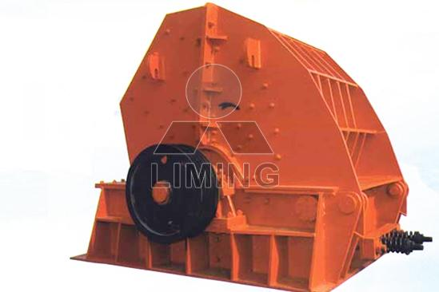
Technical Data:
Name | Model | Max feed size (mm) | Handling capacity (t/h) | Power of motor (kW) | Weight (t)
hammer crusher  (hammer mill) | PC400×300 | 30 | 5-8 | 11 | 1.5
hammer crusher  (hammer mill) | PC600×400 | 100 | 10-15 | 18.5 | 3
hammer crusher  (hammer mill) | PC800×600 | 150 | 20-25 | 55 | 7
hammer crusher  (hammer mill) | PC800×1000 | 280 | 20-50 | 110 | 12
Circuit Type  Hammer Mill | PCH0606 | 200 | 18-30 | 30 | 17
Circuit Type  Hammer Mill | PCH0808 | 250 | 30-50 | 45 | 29
Circuit Type  Hammer Mill | PCH1010 | 300 | 45-80 | 90 | 52
Contact Us:
Thank you for your interest in Liming Heavy Industry (Shanghai). Please feel free to use any of the methods below to get in touch with us.
Office Tel: 0086-21-33901608
Fax: 0086-21-58377628
Email: sales@shcrusher.com
MSN Online: shcrusher@hotmail.com
Address: No.201-34, Huaxia 3rd Road, Pudong New Area, Shanghai, China.
Postcode: 201200

For more detailed information, please click here: http://www.shanghai-crusher.com/

