Product

Brief Introduction:

HGM Micro Powder Mill (Full name is HGM series three-ring & medium-speed micro-powder mill) is designed basing on our 20 years’ manufacturing experience, absorbing the Swedish advanced machine manufacturing techniques. It is a new type of mill for making super fine powder through more than 20 times of test and improvement. It is the latest type of product of micro-powder mill that leads the world tide. It is the grinding equipment used to process fine powder and super-fine powder.

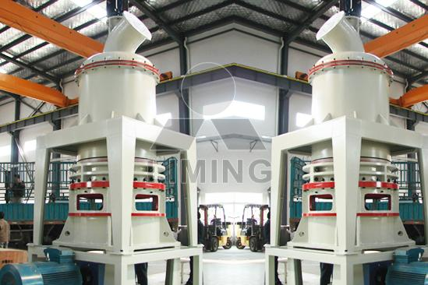

Highlights:

(1) Low investment cost. With the same product fineness and generator power, it has low investment cost, short return period and twice more output compared with the airflow mill, stirring mill or ball mill.

(2) High powder output. With the same fineness and power consumption, its powder output is more than the airflow mill or stirring mill by 45%.

(3) Low wear and long service time of wear parts. All the wear parts are made of domestic and foreign anti-friction material. Their service life is longer than that of the wear parts of ordinary mill equipment. Generally, they can be used for more than one year.

(4) High security and reliability. The operation which is inside of the grinding chamber is safe and reliable. Compared with an ordinary mill, there is not rolling axletree or screws, so there is no problem of wear of the axletree and other sealed parts, and it avoids the problem that the machine is damaged due to loosen screws.

(5) High fineness of finished product. The final fineness can reach d97≤5μm through one-time processing.

(6) Pollution-free. It adopts an efficiency pulse dust collector, so there is no dust pollution in the complete operation process. In addition, it is equipped with a muffler and sound proofing room so that the pollution and noise can be reduced in accordance with the environment-protection standard, and surrounding environment is protected.

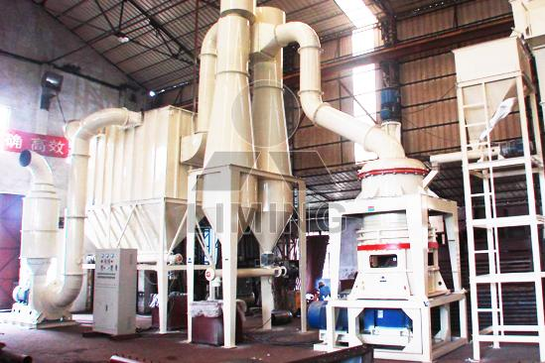

Working Principle:

The motor drives the main shaft and every turnplate through the reducer. The reducer drives dozens of rollers to rotate against race way of ring through pin. Small material crushed by hammer crusher is transported into hopper by elevator, and then vibrating feeder shall feed material to the central part of upper turnplate evenly. The material falls to circle under the centrifugal force and comes down to raceway of ring to be crushed into powder. After grinded in the first race way, the material goes to the second and third turnplate. The blower inhales the external air into the mill and carries the powder after third turnplate into powder-separator. Turbine in the separator makes the coarse powder drop down and regrinded and the fine powder shall go into cyclone powder collector together with air current and go down through discharge valve as final product; at the same time, air current with a little dust goes out through blower and muffler after purified by filter.

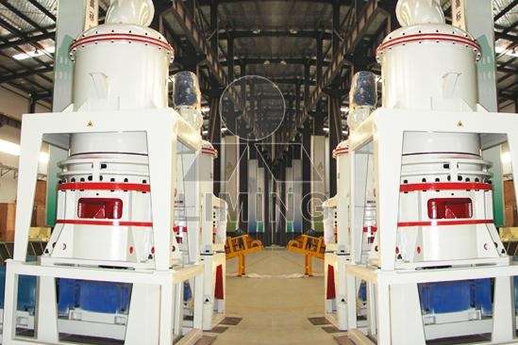

Technical Data:
TABLE 1
Model | HGM80 | HGM100
Roller number | 21 | 27
Ring Diameter (mm) | Φ800 | Φ1000
Ring number | 1x3 | 1x3
Main unit speed(mm) | 180-250 | 150-200
Max. feeding size(mm) | 10 | 10
Final size (mesh) | 325-2500 | 325-2500
Capacity (kg/h) | 400-4500 | 900-6500
Overall dimension (m) | 13.5×4×6.5 | 18x4.5x8.6
TABLE 2
Name | Item | Unit | Specifications & Technical Data
Name | Item | Unit | HGM80 | HGM100
Motor for main frame | Model |  | Y2-250M-4 | Y2-315M-6
Motor for main frame | Power | kW | 55 | 110
Motor for separator | Model |  | Y2-180M-4 | Y2-200M-4
Motor for separator | Power | kW | 18.5 | 30
Motor for Elevator | Model |  | Y100L-4 | Y112M-4
Motor for Elevator | Power | kW | 3 | 3
Motor for Blower | Model |  | Y2-255M-2 | Y2-280M-2
Motor for Blower | Power | kW | 45 | 75
Motor for Hammer Crusher | Model |  | PC400x300 | PC600x400
Motor for Hammer Crusher | Power | Kw | 11 | 18.5
Motor of Vibrating Feeder | Model |  | GZ1F | GZ1F
Motor of Vibrating Feeder | Power | Kw | 0.06 | 0.06
Motor of discharge valve | Model |  | ZJD200 | ZJD200
Motor of discharge valve | Power | Kw | 0.75 | 0.75
Impulse bag filter | Model |  | DMC120 | DMC184
Impulse bag filter | Power |  | 7.5

Contact Us:
Thank you for your interest in Liming Heavy Industry (Shanghai). Please feel free to use any of the methods below to get in touch with us.
Office Tel: 0086-21-33901608
Fax: 0086-21-58377628
Email: sales@shcrusher.com
MSN Online: shcrusher@hotmail.com
Address: No.201-34, Huaxia 3rd Road, Pudong New Area, Shanghai, China.
Postcode: 201200

For more detailed information, please click here:
http://www.shanghai-crusher.com/

