Product

Brief Introduction:

Our company has designed and produced seven types of grinding mills according to fineness of final product, capacity and various industrial uses. Fineness rang is between 0.005mm and 2mm, the highest capacity is about 100 t/h, dry and wet production can be realized.

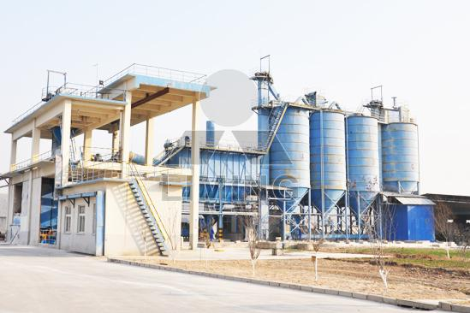

Highlights:

(1) The ladder-shaped rollers and rings improve crushing efficiency greatly. The rollers and ring are designed in the main machine of an inverted trapezium, which control the materials slip velocity between rollers and rings. They can extend the grinding time, and enhance the crushing effect.

(2) The press springs with balancing and pressurized function and the forming resilient connection with steady and vibration reducing function are invented into our machines. The powder classifier adopts high density impeller, which can increase precision of powder and capacity.

(3) There is high-efficiency and energy-saving blower installed on our machine. The efficiency of prismatic blade equipped on the traditional machine is only 62%, but the efficiency of the energy saving blower, whose impeller and blade are both stamping, is 85%.

(4) There is convenient impeller adjusting device. The clearance between housing and ending of powder classifiers blade also effects fineness. Our mill is convenient to adjust the fineness.

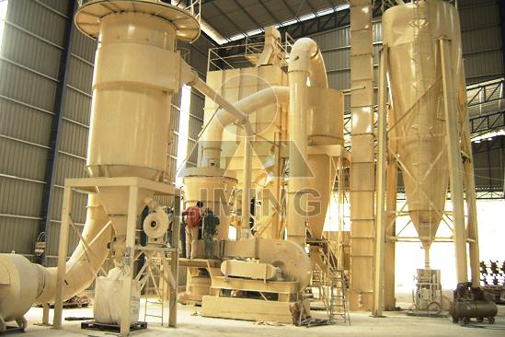

Working Principle:

Large materials are crushed by Jaw crusher to the needed sizes firstly, then the materials are elevated to storage hopper by bucket elevator, thirdly, the materials are fed into the grinding chamber for grinding by vibrating feeder even and continuously. The powder after grinding goes upwards together with the airflow, after separated by powder separator, the powder which can meet the fineness requirement enters into the cyclone powder collector through pipe together with the airflow, and then is discharged from the discharge valve as final product. The airflow is sucked into centrifugal blower through wind recycling pipe at the upper part of cyclone powder collector. The mainframe is driven by the speed reducer through the central axis in the mill. The quincunx stand connects with the upper part of central axis, at the quincunx stand, rollers are set and by which the vibrating pivot formed. Below the quincunx stand and rollers is shovel system. Materials are fed into the space between turning rollers and shovels, and then are grinded by the pressure produced by turning rollers, thus powder is made.

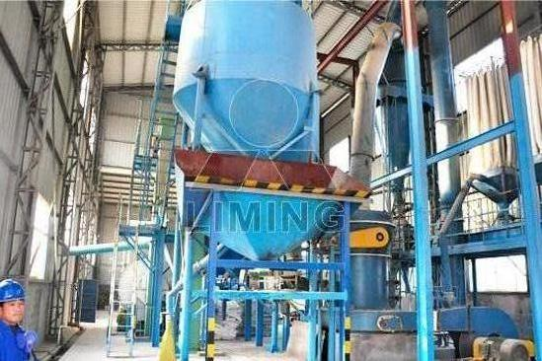

Technical Data:

vibrating feeder +jaw crusher + ultrafine mill

Technical parameter can refer to vibrating feeder, jaw crusher, ultrafine mill.
Contact Us:
Thank you for your interest in Liming Heavy Industry (Shanghai). Please feel free to use any of the methods below to get in touch with us.
Office Tel: 0086-21-33901608
Fax: 0086-21-58377628
Email: sales@shcrusher.com
MSN Online: shcrusher@hotmail.com
Address: No.201-34, Huaxia 3rd Road, Pudong New Area, Shanghai, China.
Postcode: 201200

For more detailed information, please click here:
http://www.shanghai-crusher.com/

