European Type Impact Crusher
Brief Introduction:
European Type Impact Crusher is our latest generation of product with the international advanced-level quality, which is designed and produced based on Liming Heavy Industry absorbing the latest technology of impact crusher in the world. The impact crusher with two crushing cavities can simplify the process flow in the coarsely -medium crushing operation process. While the impact crusher with three crushing cavities can be used in the fine crushing and ultra fine crushing.
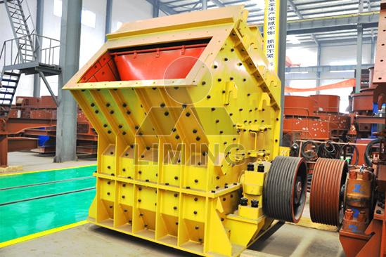
Highlights:
(1) Adopting the world-level manufacturing process; selecting manufacturing material at the most significant end.
(2) Design of the heavy rotor and strict detection means guarantee high quality of rotor.
(3) Integral cast steel structure is adopted for bearing base.
(4) Higher reliability of plate hammer with unique fixing device.
(5) Less time of downtime and maintenance with improved adjustment device.
(6) Its own open-top device can rapidly complete replacement for spare parts such as hammer head.
(7) The larger bearing is adopted and with higher bearing capacity.
(8) The stability and reliability can be guaranteed through analyzing the rotor.
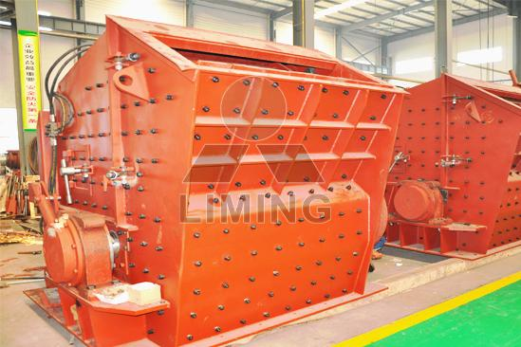
Working Principle:
This type of impact crusher use impact energy to crushing the materials. When materials enters the working area of plate hammer, they are impacted then crushed by plate hammer at a high speed, and are thrown into the impact device installed at the upper part of the rotor for re-crushing, then rebounded into the working area of plate hammer from the impact scaleboard for re-crushing. This process is repeated until materials are crushed into demanded granularity and are discharged from lower part of the machine. The granularity and the shape of the materials can be changed by adjusting the gap between the impact frame and the rotor shaft. Spring safety device is adopted behind impact plate of the machine. When non-broken materials enter the crushing cavity, the front and rear impact frame fall.
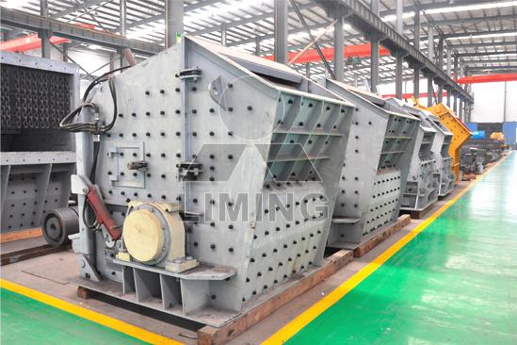
Technical Data:
Table 1: for crusher with three crushing chambers
Model | Rotor size (mm) | Feed opening (mm) | Max. Feed size (mm) | capacity (t/h) | Power (kW) | weight (t) | Overall dimension (mm)
PFW1210Ⅲ | Ф1150×960 | 570×990 | 250 | 70-120 | 90-110 | 15 | 2550×1870  ×2100
PFW1214Ⅲ | Ф1150×1400 | 570×1430 | 250 | 90-170 | 132-160 | 19 | 2550×2310  ×2100
PFW1315Ⅲ | Ф1300×1500 | 625×1530 | 300 | 180-270 | 160-200 | 25 | 2960×2570  ×2380
PFW1318Ⅲ | Ф1300×1800 | 625×1830 | 300 | 220-300 | 200-250 | 30 | 2960×2870  ×2380
PFW1415Ⅲ | Ф1400×1500 | 625×1350 | 350 | 280-350 | 200-250 | 30 | 3120x2650  x2660
Table 2: for crusher with two crushing chambers
Model | Rotor size (mm) | Feed opening (mm) | Max. Feed size (mm) | capacity (t/h) | Power (kW) | weight (t) | Overall dimension (mm)
PFW1210  Ⅱ | Ф1150×960 | 1100x1030 | 400 | 90-160 | 90-110 | 17 | 2400x1870  x2550
PFW1210  Ⅱ | Ф1150×1400 | 1100x1430 | 500 | 132-200 | 132-160 | 22 | 2400x2310  x2550
PFW1315Ⅱ | Ф1300×1500 | 1200x1530 | 600 | 180-320 | 160-200 | 29 | 2700x2570  x2800
PFW1318Ⅱ | Ф1300×1800 | 1200x1830 | 700 | 240-400 | 200-250 | 34 | 27002870  x2800
PFW1415Ⅱ | Ф1400×1500 | 1300x1530 | 700 | 300-480 | 200-250 | 30 | 2900x2700  x3000
Notice: Any change of European Type Impact Crusher technical data shall not be advised additionally.

Contact Us:
Thank you for your interest in Liming Heavy Industry (Shanghai). Please feel free to use any of the methods below to get in touch with us.
Office Tel: 0086-21-33901608
Fax: 0086-21-58377628
Email: sales@shcrusher.com
MSN Online: shcrusher@hotmail.com
Address: No.201-34, Huaxia 3rd Road, Pudong New Area, Shanghai, China.
Postcode: 201200

For more detailed information, please click here: http://www.shanghai-crusher.com/

