European Type Hammer Crusher
Brief Introduction:
The European Type Hammer Crusher is suitable for secondary and fine crushing all kinds of rocks with compressive strength less than 320MPa. European Type Hammer Crusher is widely used in mining, building materials, chemical industry, metallurgy, cement, ceramic, refractory industry and so on.
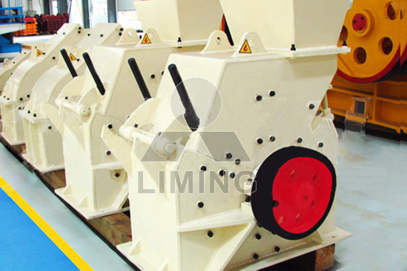
Highlights:
(1) High capacity, high crushing ratio.
(2) Simple structure, easy maintenance, easy operation.
(3) Even output granularity and electricity-saving.
(4) The water content of materials is less than 10% - 15%.
Working Principle:
European Type Hammer Crusher mainly includes case, rotor, iron bearing, grate bars and other components. There are two parts in case: the upper one and lower one which are welded after cutting. The remaining parts are connected by bolts. Inside the case, there is high manganese steel liner which can be replaced after wear and bear. European Type Hammer Crusher is installed on an array of spindles which forms the rotor together with rotary table and axis. The rotor rotates through motor and V-belt driven spindle. The hammer stretches around as the centrifugal force generated by rotation, in that way, bulk materials feed into the crushing chamber and are crushed by the high-speed movement. The standard stones pass from the grate bars below and for those not standard will again be crushed in the case till they can pass from the grate.
Technical Data:
Name | Model | Max feed size (mm) | Handling capacity (t/h) | Power of motor (kW) | Weight (t)
hammer crusher  (hammer mill) | PC400×300 | 30 | 5-8 | 11 | 1.5
hammer crusher  (hammer mill) | PC600×400 | 100 | 10-15 | 18.5 | 3
hammer crusher  (hammer mill) | PC800×600 | 150 | 20-25 | 55 | 7
hammer crusher  (hammer mill) | PC800×1000 | 280 | 20-50 | 110 | 12
Circuit Type  Hammer Mill | PCH0606 | 200 | 18-30 | 30 | 17
Circuit Type  Hammer Mill | PCH0808 | 250 | 30-50 | 45 | 29
Circuit Type  Hammer Mill | PCH1010 | 300 | 45-80 | 90 | 52
Contact Us:
Thank you for your interest in Liming Heavy Industry (Shanghai). Please feel free to use any of the methods below to get in touch with us.
Office Tel: 0086-21-33901608
Fax: 0086-21-58377628
Email: sales@shcrusher.com
MSN Online: shcrusher@hotmail.com
Address: No.201-34, Huaxia 3rd Road, Pudong New Area, Shanghai, China.
Postcode: 201200

For more detailed information, please click here: http://www.shanghai-crusher.com/

