Product

Brief Introduction:

Along With extension and rebuild of the city, the administrator would have to face the construction waste which is an intractable problem and an important link that affects civilization of the city. How to process the construction waste? Is there any new machinery or new craft to utilize the construction wastes?

By the above situation, Liming Corporation has successfully explored a new technology of utilizing the construction waste after years of research. Using the special machinery, the construction waste is crushed and screened, then is widely used in cement brick, pavement and construction. This new technology has truly reused the construction waste, will benefit the state and people. And it provides a new development idea for the urban development.

We will work together with you and push ourselves to work hard for the civilization of the city.

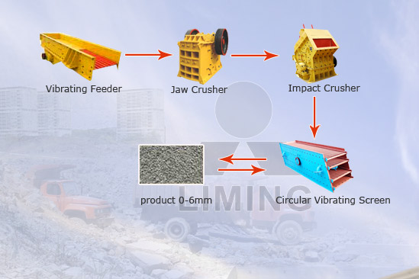

Highlights:

Recycled construction wastes have outstanding characters as below:

(1) High utilization rate

(2) Low production cost

(3) Wide using range

(4) Environmental protection

(5) High economic benefit

Working Principle:

Recycling of construction waste should be to feature different crushing equipment, screening equipment, transmission equipment and equipment to reduce harmful particles, along with reasonable production process. Large items of waste concrete wall “given” into the mobile crushing plant, after crushing, screening, delivery, and a number of processing to reduce toxins, and finally created uniform contaminants from your concrete piles of grain, that has been crushed construction waste will probably be classified Be re-used. Mainly useful for masonry debris and sand contaminants, may be strongly related pathways and bike pathways, stone road base, building materials and concrete, sports venues.

Technical Data:
Vibrating feeder +jaw crusher + impact crusher + circular vibrating screen

Technical parameters can refer to vibrating feeder, jaw crusher, impact crusher, circular vibrating screen.

Contact Us:
Thank you for your interest in Liming Heavy Industry (Shanghai). Please feel free to use any of the methods below to get in touch with us.
Office Tel: 0086-21-33901608
Fax: 0086-21-58377628
Email: sales@shcrusher.com
MSN Online: shcrusher@hotmail.com
Address: No.201-34, Huaxia 3rd Road, Pudong New Area, Shanghai, China.
Postcode: 201200

For more detailed information, please click here:
http://www.shanghai-crusher.com/

