Combination Mobile Crusher
Brief Introduction:
The complete combination mobile crusher is the Combination Crushing plant. It is combined with the high-performance crusher, the high-performance PE series jaw crusher and high-performance vibrating screen, belt conveyer and belt conveyer under the screen which are integrated with the crusher, as well as integrated vehicle-mounted motor and electrical control cabinet. It is widely used for the crushing and screening work in the road and bridge construction, urban construction, metallurgy, energy sectors.
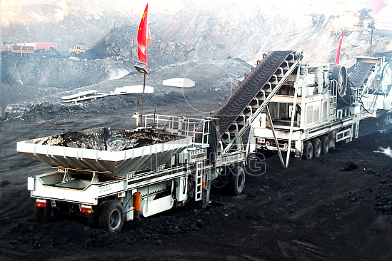
Highlights:
(1) It is economical and applicable to the small and medium sized customers.
(2) It is a multi-unit integrated and fully automatic system; the self-mounted devices include conveying and screening.
(3) It is the complete and independent crushing pioneer equipment.
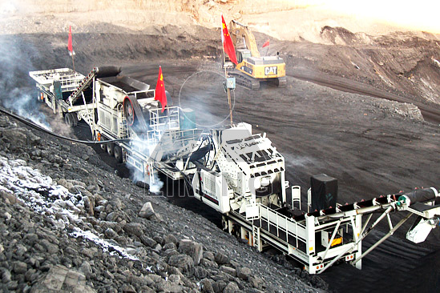
Working Principle:
When working, materials can enter into the crusher to the desired particle size directly. Through circular vibrating screen to screen out different specifications of aggregate finished products and then stacked or transport by the conveyor. As the models of mobile crushing plant using a new efficient crusher, it can realize that material processing can be in one step, the product shape evenly, greatly improving efficiency.
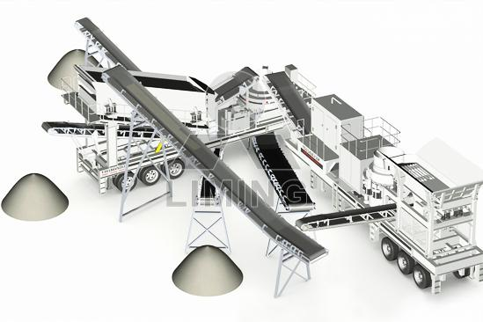
Technical Data:
Combination Mobile Crusher
Model  Technical data | Y3S23G91 E46E51B | Y3S23G83 E46Y55B | Y3S54G83 E57Y75B | Y3S84G83 F00V71B | Y3S48G93 E69Y55K
Transportation Length (mm) | 13000 | 14000 | 15500 | 16800 | 15500
Transportation Width (mm) | 2700 | 2700 | 2800 | 2800 | 2800
Transportation Height (mm) | 4200 | 4200 | 4200 | 4200 | 4200
Maximum Length (mm) | 14500 | 16000 | 17000 | 19400 | 18000
Maximum Width (mm) | 2800 | 2800 | 2900 | 3150 | 3150
Maximum Height (mm) | 5400 | 5400 | 5600 | 6000 | 6000
Weight (T) | 41 | 48 | 58 | 60 | 63
Tire Configuration | Dualaxial | Dualaxial | Dualaxial | Triaxial | Triaxial
Primary Crusher | PE400X600 | PE400X600 | PE500X750 | PF-1010 | PE600X900
Secondary crusher | PEX250X1000 | PYB900 | CS75 | VSI-7611 | PYB900
Belt conveyor under Vibrating Screen | B500X6M | B500X6M | B650X7M | B800X7M | B800X7M
Belt conveyor above Vibrating Screen | B500X13M | B500X14M | B650X14M | B650X18M | B800X15M
Main belt conveyor | B500X8M | B500X8M | B650X9M | B650X10M | B800X14M
Belt conveyor for re-crushing material |  |  |  |  | B650X10M
Vibrating Feeder | GZD-  950X150 | GZD-  850X3000 | GZD-  850X3000 | GZD-  960X3800 | GZD-  960X3800
Vibrating Screen | 3YZS1237 | 3YZS1237 | 3YZS1548 | 3YZS1848 | 3YZS1848
Mobile combination plant with vibrating feeder, impact crusher & vibrating screen
Model  Technical data | Y3S54G83F00 | Y3S84G83F20 | Y3S86G93F24 | Y3S26G14F35
Transportation Length (mm) (If there is a diesel generator) | 17000 | 17600 | 16800 | 17000
Transportation Length (mm) (If there is a diesel generator) | 17000 | 17600 | 17800 | 18500
Transportation Width (mm) | 2700 | 2900 | 2900 | 3300
Transportation Height (mm) | 3900 | 4400 | 4400 | 4500
Maximum Length (mm) | 18500 | 19200 | 20800 | 21500
Maximum Width (mm) | 2800 | 3150 | 3150 | 3500
Maximum Height (mm) | 5600 | 6000 | 6600 | 6600
Weight (T) | 49 | 56 | 66 | 78
Tire Configuration | Dualaxial | Dualaxial | Triaxial | Triaxial
Impact crusher | PF-1010 | PF-1210 | PF-1214 | PF-1315
Belt conveyor under Vibrating Screen | B650X7M | B650X7M | B800X8M | B1000X8M
Belt conveyor above Vibrating Screen | B500X13M | B650X14M | B800X15M | B1000X16M
V shape belt conveyor |  |  | B800X14M | B1000X15M
Belt conveyor for re-crushing material | B500X7M | B500X8M | B800X8.5M | B1000X8.5M
Vibrating Feeder | GZD-850X3000 | GZD-850X3000 | GZD-960X3800 | GZD-1100X4200
Vibrating Screen | 3YZS1548 | 3YZS1848 | 3YZS1860 | 3YZS2160
Jaw crusher & Vibrating screen combination mobile crushing plant
Model  Technical data | Y3S23G91E46B | Y3S54G83E57B | Y3S86G93E69K | Y3S26G14E71K
Transportation Length (mm) (If there is a diesel generator) | 12500 | 16400 | 16800 | 16800
Transportation Length (mm) (If there is a diesel generator) | 12500 | 17000 | 17300 | 18600
Transportation Width (mm) | 2700 | 2700 | 2900 | 3300
Transportation Height (mm) | 3900 | 3900 | 4200 | 4500
Maximum Length (mm) | 14000 | 18400 | 19000 | 19000
Maximum Width (mm) | 2800 | 2900 | 3150 | 3500
Maximum Height (mm) | 5600 | 6000 | 6400 | 6400
Weight (T) | 34 | 46 | 62．5 | 78
Tire Configuration | Dualaxial | Dualaxial | Triaxial | Triaxial
Jaw Crusher | PE400X600 | PE500X750 | PE600X900 | PE750X1060
Belt conveyor under Vibrating Screen | B500X6M | B650X7M | B800X8M | B800X8M
Belt conveyor above Vibrating Screen | B500X10.5M | B650X13M | B800X15M | B1000X16M
V shape belt conveyor |  |  | B800X14M | B1000X15M
Belt conveyor for re-crushing material | B500X6M | B650X8M | B650X6M | B650X7M
Vibrating Feeder | GZD-950X150 | GZD-850X3000 | GZD-960X3800 | GZD-1100X4200
Vibrating Screen | 3YZS1237 | 3YZS1548 | 3YZS1860 | 3YZS2160
Cone crusher & Vibrating screen combination mobile crushing plant
Model  Technical data | Y3S54G83Y55K | Y3S54G83Y75K | Y3S86G14Y160K | Y3S26G14Y220K
Transportation Length (mm) (If there is a diesel generator) | 13500 | 14000 | 16700 | 16700
Transportation Length (mm) (If there is a diesel generator) | 14500 | 16000
Transportation Width (mm) | 2700 | 2700 | 2900 | 3300
Transportation Height (mm) | 4000 | 4000 | 4400 | 4400
Maximum Length (mm) | 14000 | 14600 | 19000 | 19000
Maximum Width (mm) | 2800 | 2800 | 3150 | 3500
Maximum Height (mm) | 6200 | 6200 | 6700 | 6700
Weight (T) | 48 | 54 | 72 | 71
Tire Configuration | Dualaxial | Dualaxial | Triaxial | Triaxial
Cone crusher | PYB900 | CS75 | CS160 | HPC-220
Belt conveyor under Vibrating Screen | B650X7M | B650X7M | B800X8M | B1000X8M
Belt conveyor above Vibrating Screen | B650X15M | B650X15M | B800X15M | B1000X16M
V shape belt conveyor | B650X14M | B650X14M | B800X14M | B1000X15M
Belt conveyor for re-crushing material | B500X3.5M | B500X4M | B650X3M | B650X3M
Vibrating feeder | GZD-850X3000 | GZD-850X3000 | GZD-1100X4200 | GZD-1100X4200
Vibrating Screen | 3YZS1548 | 3YZS1548 | 3YZS1860 | 3YZS2160

Contact Us:
Thank you for your interest in Liming Heavy Industry (Shanghai). Please feel free to use any of the methods below to get in touch with us.
Office Tel: 0086-21-33901608
Fax: 0086-21-58377628
Email: sales@shcrusher.com
MSN Online: shcrusher@hotmail.com
Address: No.201-34, Huaxia 3rd Road, Pudong New Area, Shanghai, China.
Postcode: 201200

For more detailed information, please click here: http://www.shanghai-crusher.com/

