Product

Brief Introduction:

In industrial production, the belt conveyor can be used as a link contributing to the continuous production between production machinery equipments, so as to achieve the continuity and automation during the whole production process, to improve the productivity and reduce the labor strength. It is widely applied in the conveying and production lines in mining, metallurgy, chemical, casting, and building material industries, as well as other production sectors, such as the construction site of a hydropower station and a port to convey bulk materials and end products. According to the process requirements, the conveying work can be done with a single belt conveyor, or with a horizontal or slant conveying system consisting of several belt conveyers, or of the belt conveyor and other conveying equipments to meet different demands of the operation line with different types of work. The belt conveyor can be used in the environment with the temperature ranging from －20℃to +40℃, and the temperature of the material being conveyer is below 50℃. The conveying distance of the belt conveyor manufactured by our company may be determined according to customers' demands.

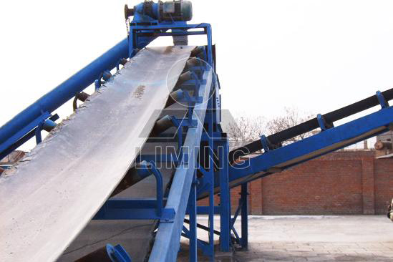

Highlights:

The belt moves according to the friction transmission principle, with advantages of large conveying capability, long conveying distance, stable conveying, non-existence of relative movement between the material and the belt, low noise, simple structure, easy to maintain, little energy consumption, part standardization, etc.

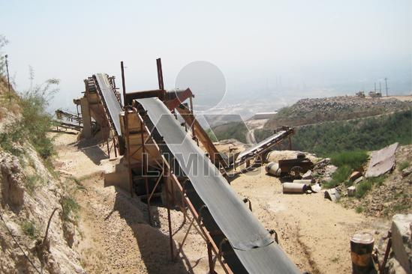

Working Principle:

The belt conveyor mainly consists of the rack, conveying belt, belt roller, tension device, transmission device. The machine body is made of the high-quality steel plates connected with each other, forming a rack based on the height difference between the front and back legs. The plane is slant with a certain slant angle. The belt roller, carrier roller, etc are installed on the rack, used to drive and support the conveying belt. The driving mode includes speed-reducing motor driving and electric-roller driving.

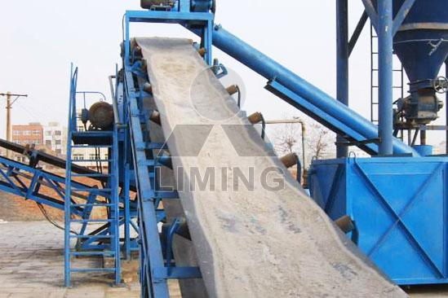

Technical Data:
Belt Width(mm) | Belt Length (m) / Power (kW) |  |  | Belt Speed (m/s) | Capacity (t/h)
500 | ≤12/3 | 12-20/4-5.5 | 20-30/5.5-7.5 | 1.3-1.6 | 45-100
650 | ≤12/4 | 12-20/5.5 | 20-30/7.5-11 | 1.3-1.6 | 70-120
800 | ≤10/4 | 10-15/5.5 | 15-30/7.5-15 | 1.3-1.6 | 120-180
1000 | ≤10/5.5 | 10-20/7.5-11 | 20-40/11-22 | 1.3-2.0 | 160-250
1200 | ≤10/7.5 | 10-20/11 | 20-40/15-30 | 1.3-2.0 | 200-400

Contact Us:
Thank you for your interest in Liming Heavy Industry (Shanghai). Please feel free to use any of the methods below to get in touch with us.
Office Tel: 0086-21-33901608
Fax: 0086-21-58377628
Email: sales@shcrusher.com
MSN Online: shcrusher@hotmail.com
Address: No.201-34, Huaxia 3rd Road, Pudong New Area, Shanghai, China.
Postcode: 201200

For more detailed information, please click here:
http://www.shanghai-crusher.com/

