Product

Brief Introduction:

In the highway asphalt concrete road surface, both SMA and Super pave technology need high requirement of the shape and rank of aggregate. Especially to the content of needle plate type in the basalt, the former impact crusher processing chart cannot meet the requirement any longer. Therefore, our company puts up the newest crushing and screening processing chart-VI series of Vertical Shaft Impact Crusher to meet the need. The high-quality aggregate produced by this production line is widely used in road surface of many highways.

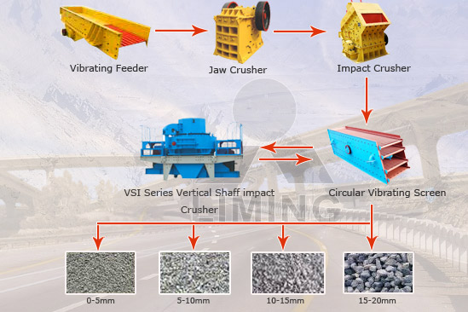

Highlights:

(1) The quality of the product is very high. Content of needle plate type is no more than 5%. A diabase in Africa, once adopted Jaw Crusher and Impact Crusher. But content of needle plate type is more than 10%, resulting the bad sell of its product. After using VSI Series Vertical Shaft Impact Crushers, the content of needle plate type in the product is reduced to 4.7%.

(2) The production improves 50% compared with utilizing Impact Crusher as the final processing of crushing.

(3) Because we utilize Impact Crusher as the secondary crusher, and Vertical Shaft Impact Crusher consumes little metal, the consumption of wear-parts is reduced greatly in the whole process.

Working Principle:

Vibrating feeder feeds the big material into jaw crusher for primary crushing. After first crush, the material will be reshaped and processed by cone crusher or impact crusher. Vertical shaft impact crusher plays the role of tertiary crushing, and then vibrating screen separates product. After separating, the parts that can meet standard will be transferred away as final products, while the other parts will be returned to crusher, thus forming a closed circuit until product size is up to the crusher model and screen model.

Technical Data:
Vibrating feeder+ jaw crusher +HP series High Efficiency Hydraulic Cone Crusher + circular vibrating screen
VSI Series Vertical Shaft Impact Crusher + Circular vibrating screen
Technical parameters can refer to vibrating feeder, jaw crusher, HP series High Efficiency Hydraulic Cone Crusher, circular vibrating screen, VSI.

Contact Us:
Thank you for your interest in Liming Heavy Industry (Shanghai). Please feel free to use any of the methods below to get in touch with us.
Office Tel: 0086-21-33901608
Fax: 0086-21-58377628
Email: sales@shcrusher.com
MSN Online: shcrusher@hotmail.com
Address: No.201-34, Huaxia 3rd Road, Pudong New Area, Shanghai, China.
Postcode: 201200

For more detailed information, please click here:
http://www.shanghai-crusher.com/

