Product

Brief Introduction:

Ball mill is suitable to grind various mineral and other materials, which is widely used in various industries such as beneficiation, construction materials, chemical industry, etc. It has two ore grinding ways: dry way and wet way. According to discharge type of finished powder, it can be divided into two kinds: grid type and overflow type. Ball mill is widely used to process cement, silicate product, new building product, new building materials, fireproof materials, fertilizer, ferrous and non-ferrous metal ore beneficiation, glass, ceramics, etc.

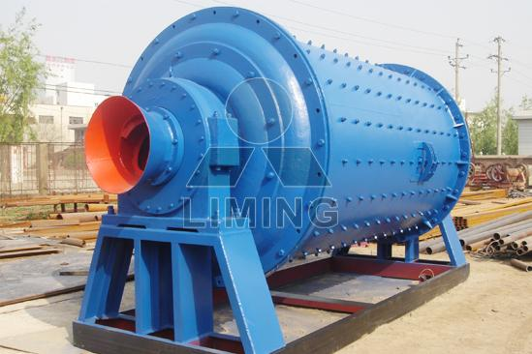

Highlights:

(1) Ball mill is an efficient tool for grinding many materials into fine powder.

(2) The ball mill is used to grind many kinds of mine and other materials, or to select the mine.

(3) Ball mill is widely used in building material, and chemical industry.

(4) There are two ways of grinding: the dry way and the wet way.

(5) Ball mill can be divided into tabular type and flowing type according to different expelling mine.

(6) To use the ball mill, the material to be ground is loaded into the neoprene barrel that contains grinding media.

(7) As the barrel rotates, the material is crushed between the individual pieces of grinding media that mix and crush the product into fine powder over a period of several hours.

(8) The longer the ball mill runs, the finer the powder will be.

(9) Ultimate particle size depends entirely on how hard the material you're grinding is, and the time how long the ball mill runs.

(10) Our ball mills have been used to grind glass, powder food products, create custom varnishes, make ceramic glaze, and powder various chemicals.

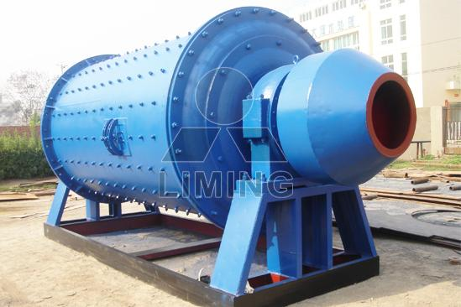

Working Principle:

Materials enter into the first grinding chamber through hollow shaft. There are liner of ladder type or curve type, and steel balls of different specifications in the first grinding chamber. The centrifugal force caused by turning of he barrel take balls into a certain height inside the chamber, and then balls fall down, have striking and grinding effect on materials. Materials after primary grinding in the first grinding chamber is fed into eh second grinding chamber through single layer chamber dividing plate. There are flat liners and steel balls in the second grinding chamber. The balls make further grinding effect on materials. Finished powder which meet requirement is discharged through discharge grade plate and the grinding work is finished.

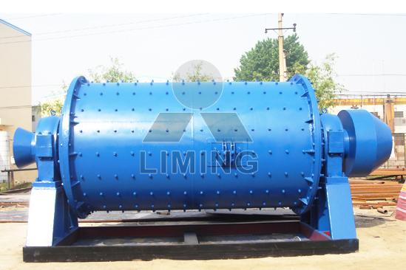

Technical Data:
Model |  |  | 3R2115 | 3R2615 | 3R2715 | 3R3016 | 4R3216
Roller | Number |  | 3 | 3 | 3 | 3 | 4
Roller | Diameter (mm) |  | 210 | 260 | 270 | 300 | 320
Roller | Height (mm) |  | 150 | 150 | 150 | 160 | 160
Ring | Inside diameter (mm) |  | 630 | 780 | 830 | 880 | 970
Ring | Height (mm) |  | 150 | 150 | 150 | 160 | 160
Maximum feed size (mm) |  |  | 15 | 15-20 | 15-20 | 15-20 | 20-25
Output size (mm) |  |  | 0.044-0.165 | 0.044-0.165 | 0.044-0.165 | 0.044-0.165 | 0.044-0.165
Power of main frame (kW) |  |  | 15 | 18.5 | 22 | 30 | 37
Fineness of final product (mm) | 0.165 | capacity (t/h) | 1.2-1.8 | 1.8-2.5 | 2.3-2.8 | 2.6-3.2 | 3.2-4.5
Fineness of final product (mm) | 0.075 | capacity (t/h) | 0.6-1.2 | 1.2-1.8 | 1.8-2.3 | 1.9-2.6 | 2.4-3.1
Fineness of final product (mm) | 0.044 | capacity (t/h) | 0.6-1.0 | 0.8-1.2 | 0.9-1.7 | 1-1.9 | 1.8-2.5

Contact Us:
Thank you for your interest in Liming Heavy Industry (Shanghai). Please feel free to use any of the methods below to get in touch with us.
Office Tel: 0086-21-33901608
Fax: 0086-21-58377628
Email: sales@shcrusher.com
MSN Online: shcrusher@hotmail.com
Address: No.201-34, Huaxia 3rd Road, Pudong New Area, Shanghai, China.
Postcode: 201200

For more detailed information, please click here:
http://www.shanghai-crusher.com/

